
MIDISENSE: REAL-TIME MIDI PERFORMANCE ANALYSIS AND CONTEXTUAL AI TUTORING FOR BRIDGING MUSIC LEARNING AND PRODUCTION
FINAL YEAR
PROJECT REPORT
Submitted by
Surya Raj M R (23619125)
Libi Jassin W (23619120)
Monish S (23619123)
in partial fulfilment for the award of the degree of
BACHELOR OF TECHNOLOGY
IN
ARTIFICIAL INTELLIGENCE AND MACHINE LEARNING

DEPARTMENT OF ARTIFICIAL INTELLIGENCE AND MACHINE LEARNING
SCHOOL OF ENGINEERING
VELS INSTITUTE OF SCIENCE, TECHNOLOGY AND ADVANCED STUDIES (VISTAS)
CHENNAI
OCTOBER 2026
BONAFIDE CERTIFICATE
Certified that this project “MIDISense: Real-Time MIDI Performance Analysis and Contextual AI Tutoring for Bridging Music Learning and Production” is the bonafide work of Surya Raj M R (23619125), Libi Jassin W (23619120) and Monish S (23619123) who carried out the project work under my supervision. Certified further that, to the best of my knowledge, the work reported here does not form part of any other project report or dissertation on the basis of which a degree or award was conferred on an earlier occasion on this or any other candidate.

SIGNATURE OF THE HOD  Dr. K. Ulaga Priya, M.E., Ph.D.  Associate Professor & Head  Department of AI & ML  School of Engineering  VISTAS  Chennai - 600 117 | SIGNATURE OF THE SUPERVISOR  Dr. K. Ulaga Priya, M.E., Ph.D.  Associate Professor & Head  Department of AI & ML  School of Engineering  VISTAS  Chennai - 600 117

Submitted for the Project Work and Viva-Voce examination held on ……………… at Vels Institute of Science, Technology and Advanced Studies (VISTAS), Chennai – 600 117.

INTERNAL EXAMINER | EXTERNAL EXAMINER
ACKNOWLEDGEMENT
It is certainly a great delight and proud privilege to acknowledge the help and support we received from the positive minds around us in making this venture a successful one. The infrastructural support with all kinds of lab facilities has been a motivating factor in the completion of this project work, all because of our FOUNDER & CHAIRMAN, Dr. Ishari K. Ganesh, and it is with great pleasure that we take this opportunity to thank him. We are grateful to our HEAD OF THE DEPARTMENT, Dr. K. Ulagapriya, for her continuous support for the project, from initial advice and contacts in the early stages of conceptual inception, and through on-going advice and encouragement to this day. We extend our warmest thanks to our INTERNAL GUIDE, Dr. K. Ulagapriya, Associate Professor, Department of AI & ML, who has patiently guided us and provided invaluable advice and help throughout the work. We are thankful to our Project Coordinator, Ms. S.J. Kavitha. We would like to express our greatest gratitude to our staff members, Librarian, and non-teaching staff members of the Computer Centre, who have helped and supported us throughout. Last but not the least, we wish to thank our parents and friends for their individual support and interest, who inspired and encouraged us to go our own way, without them we would be unable to complete this project

SURYA RAJ M R - 23619125
LIBI JASSIN W - 23619120
MONISH S - 23619123

TABLE OF CONTENTS
ABSTRACT 7
LIST OF FIGURES 8
LIST OF TABLES 9
LIST OF ABBREVIATIONS 10
INTRODUCTION 11
1.1 General 11
1.2 Problem Description 12
1.3 Existing System 12
1.4 Proposed System 13
1.5 Objectives 13
1.6 Scope of the Project 14
1.7 Contributions 14
1.8 Modules 15
1.9 Summary 16
LITERATURE REVIEW 17
2.1 MIDI and Symbolic Music Representation 17
2.2 Score Following and Performance Alignment 17
2.3 Audio Transcription and Expressive Performance Modelling 17
2.4 Piano Performance Assessment and AI-Based Coaching 18
2.5 Music Education Software 18
2.6 Intelligent Tutoring Systems 18
2.7 Large Language Models 19
2.8 Existing Systems and Limitations 19
2.9 Research Gap 20
2.10 Summary 20
SYSTEM DESIGN 21
3.1 Existing System 21
3.2 Proposed System 21
3.3 System Architecture 22
3.4 Overall Workflow 23
3.5 System Modules 24
3.6 Data Flow 24
3.7 Hardware Requirements 25
3.8 Software Requirements 26
3.9 Non-Functional Requirements and Design Considerations 26
3.10 Summary 27
IMPLEMENTATION AND METHODOLOGY 28
4.1 Development Approach and Infrastructure 28
4.2 Reference Material and Data 28
4.3 MIDI Input and Event Capture 28
4.4 Practice State and Statistics 29
4.5 Performance Analysis: Timing Accuracy 30
4.6 Performance Analysis: Note Correctness 31
4.7 Performance Analysis: Dynamics and Feedback Generation 32
4.8 Contextual AI Tutor: Flask Backend and Ollama with Gemma 3:4b 32
4.9 Learning Workflow: Assessment and Lesson Progression 33
4.10 Sequencer and Music Production Access 34
4.11 User Interface 34
4.12 Execution Flow 35
4.13 Testing and Validation Approach 36
4.14 Design Rationale 36
4.15 Summary 36
RESULTS AND DISCUSSION 38
5.1 Experimental Setup 38
5.2 Functional Testing Results 38
5.3 MIDI Capture Verification 39
5.4 Analysis Engine Validation and the Feedback Inconsistency 39
5.5 Integrated Practice Session 39
5.6 Learning Workflow and Assessment 46
5.7 Comparison with Existing Tools 47
5.8 Overall Discussion 47
5.9 Summary 47
CONCLUSION AND FUTURE WORK 48
6.1 Conclusion 48
6.2 Limitations 49
6.3 Future Scope 50
6.4 Summary 50
REFERENCES 51
APPENDIX 53
8.1 Main Source Files 53
8.2 Runtime Services and Ports 53
SOURCE CODE 54
9.1 Overview of the Source Code 54
9.2 Main Application Source Code (PianoKeyboard.jsx) 54

ABSTRACT
Artificial intelligence has changed both how people learn music and how they produce it, yet a large gap remains between learning to play an instrument and making music. Existing learning platforms concentrate on testing whether notes were played correctly, while Digital Audio Workstations (DAWs) concentrate on the production workflow and offer no tutoring. Neither explains a learner’s mistakes in terms of the music being played. This project presents MIDISense, a browser-based practice, tutoring and production-access platform that closes this gap. Instead of listening to audio, it reads the MIDI stream directly through the Web MIDI API: every note, its velocity and its timing. A performance analysis engine evaluates timing against a reference beat grid (40 ms tolerance at 120 BPM), note correctness against lesson targets, and dynamics from velocities. The analysis is passed through a Flask back end to a Gemma 3:4b language model that runs locally under Ollama, so the tutor responds to what the learner has actually just played, explains the music theory behind mistakes and suggests what to try next. A 20-question beginner assessment (pass mark 17/20), sequential lessons with Firebase-backed progress, practice statistics and a built-in sequencer connect practice with music production. The integrated prototype was tested functionally on real hardware. In a representative live practice session, the system captured 279 MIDI notes in 2 minutes 44 seconds with a reported accuracy of 80%, while the AI tutor produced real-time coaching. During assessment testing, a score of 16/20 was not accepted, and a retry scoring 17/20 passed and unlocked the production interface; Lesson 1 successfully unlocked Lesson 2. These are functional results from a single session and are not evidence of learning gains; a formal participant-based evaluation of learning outcomes remains future work.

Keywords — Artificial Intelligence, MIDI Analysis, Music Education, Contextual AI, Large Language Models (LLMs), Digital Audio Workstations (DAWs), Real-Time Performance Analysis, Intelligent Tutoring Systems, Music Production.
LIST OF FIGURES
Figure No. | Title | Pg.No
Figure 2.1 | Performance Comparison of MIDISense with Existing Music-Learning and Production Tools | 19
Figure 3.1 | Proposed MIDISense Framework for Real-Time MIDI Analysis and Contextual AI Tutoring | 23
Figure 4.1 | MIDISense User Interface | 35
Figure 5.1 | MIDI Performance Analysis Output (i) | 41
Figure 5.2 | MIDI Performance Analysis Output (ii) | 42
Figure 5.3 | AI Tutor Feedback Sample (i) | 43
Figure 5.4 | AI Tutor Feedback Sample (ii) | 44
Figure 5.5 | Live MIDI Keyboard Session (i) | 45
Figure 5.6 | Live MIDI Keyboard Session (ii) | 46
LIST OF TABLES
Table No. | Title | Pg.No
Table 1.1 | Project Objectives | 13
Table 1.2 | Target Users and Supporting Modules | 14
Table 2.1 | Comparison of Existing Approaches with MIDISense | 19
Table 3.1 | Major System Modules | 24
Table 3.2 | Data Exchanged Between the Main Modules | 25
Table 3.3 | Hardware Configuration | 25
Table 3.4 | Software and Technologies | 26
Table 4.1 | Input Sources Supported by MIDISense | 29
Table 4.2 | Rule-Based Feedback Generated from the Analysis | 32
Table 4.3 | Endpoints of the Flask Tutor Service | 33
Table 4.4 | Functions of the Lesson Store | 33
Table 5.1 | Summary of Functional Tests | 38
Table 5.2 | Representative Practice Session | 39
Table 5.3 | Values Visible in the Captured Screenshots | 40
Table 5.4 | Assessment Attempts Recorded During Testing | 46
Table 6.1 | Implementation Status of MIDISense Features | 49
Table 8.1 | Main Source Files and Their Roles | 53
Table 8.2 | Runtime Services Used by MIDISense | 53
LIST OF ABBREVIATIONS
Abbreviation | Full Form
AI | Artificial Intelligence
API | Application Programming Interface
BPM | Beats Per Minute
CORS | Cross-Origin Resource Sharing
CSS | Cascading Style Sheets
DAW | Digital Audio Workstation
GPU | Graphics Processing Unit
HTTP | Hypertext Transfer Protocol
JSX | JavaScript XML
LLM | Large Language Model
MIDI | Musical Instrument Digital Interface
ML | Machine Learning
RAM | Random Access Memory
REST | Representational State Transfer
USB | Universal Serial Bus

CHAPTER 1
INTRODUCTION

1.1 General
Digital technology has changed both how people learn music and how they make it. Beginners can now learn from mobile applications and online lessons, and producers can build complete songs inside a Digital Audio Workstation (DAW). The two activities, however, remain largely separate. Learning applications mostly check whether a student has played the right notes, while DAWs assume that the user already knows what to play and how to arrange it. A learner who wants to become a producer is left without a guide between these two stages.
MIDISense is a real-time music practice, tutoring and production-access platform that is designed to bridge this gap. It reads the Musical Instrument Digital Interface (MIDI) messages [1] sent by a keyboard or controller directly in the web browser and analyses them as they are played. MIDI describes a performance as events: it states which note was struck, the velocity with which it was struck, and the moments at which it started and ended. Because the instrument itself reports this information, no audio has to be recorded or transcribed.
A Large Language Model (LLM) tutor then uses the analysis of the learner’s own playing to coach the player, to explain mistakes in terms of music theory and to suggest what to practise next. A built-in sequencer allows the learner to record playing and to move from practising towards creating music. The system is built as a React web application with a Flask back end, and the language model, Gemma 3:4b, runs locally through Ollama so that practice data stays on the learner’s own computer.
The motivation for the project comes from three observations. First, music-learning applications are good at saying that a note was right or wrong, but they seldom explain why a mistake happened or what to do about it. Second, general-purpose chatbots can explain music theory, but they cannot see what the student has just played, so their advice is generic. Third, audio-based systems must first convert sound into notes, which adds delay and transcription errors. MIDI removes this step, and MIDISense is designed to exploit that property to answer three questions in one environment: what did I just play, what went wrong and why, and what should I do next.

1.2 Problem Description
The problem addressed by this project is how to design, implement and test a system that understands a musical performance from MIDI data, responds in real time with personalised guidance, and provides a path from practice to production within one environment. Current tools leave the following problems unsolved:
- Learning platforms focus on skill testing and give little explanation of why a mistake happened.
- DAWs focus on the production workflow and offer no tutoring about the performance being recorded.
- Audio-based tutoring systems must first transcribe sound into notes, which adds latency and transcription errors.
- General-purpose chatbots do not know what the musician is playing, so their advice is generic.
- Beginners have no single environment that connects practice, theory and production.
Several practical difficulties make the problem harder than it first appears. Feedback has to arrive while the learner is still playing, so the analysis must be light enough to run in the browser after every note. Natural expressive timing must be separated from genuine timing errors, which requires a tolerance rather than an exact match. The tutor must be grounded in the learner’s own data without sending that data to an external service. Finally, the whole system had to run on ordinary laptops, which constrained the size of the language model and the amount of computation per note.

1.3 Existing System
Existing approaches fall into five groups. Learning applications such as Yousician and Simply Piano check notes and timing against an exercise and give a score, which motivates beginners but gives little explanation. DAWs such as Ableton Live and FL Studio provide powerful recording, editing and mixing tools but no tutoring about the performance. Audio-transcription and audio-assessment systems [8], [11] convert sound into notes or into learned quality scores, which allows them to serve acoustic instruments but adds latency and transcription errors. Score-following methods [5], [6], [7] align a live performance with a known score accurately and in real time, but they do not provide pedagogical feedback. General chatbots explain theory fluently but have no access to the live performance.
Recent research has begun to add explanation to performance assessment [15], [16], [17], but these systems mostly assess audio or body motion rather than the MIDI stream itself, and none of them is connected to a music-production workflow. The existing tools are compared in detail in Section 2.8.

1.4 Proposed System
MIDISense is an AI-powered practice and learning platform that reads the MIDI stream through the Web MIDI API [27] and analyses it as it is played. When no MIDI device is available, the computer keyboard and an on-screen piano can be used as alternative inputs. A performance analysis engine evaluates timing against a reference beat grid, note correctness against the target notes of a lesson, and dynamics from note velocities, and it produces a short feedback message.
The analysis result is forwarded through a Flask back end to a Gemma 3:4b model [26] running locally under Ollama [28]. The model returns one short coaching instruction after each analysis, and a separate chat endpoint answers the learner’s questions using the current practice statistics. Around this core, a 20-question beginner assessment, a sequence of lessons with Firebase-backed progress, practice statistics and a built-in sequencer connect practice with music production.

1.5 Objectives
The objectives of this project are summarised in Table 1.1.
No. | Objective
1 | Capture MIDI note-on and note-off events from a keyboard in real time, with velocity and millisecond timestamps.
2 | Analyse timing, note correctness and dynamics from the MIDI stream and turn the analysis into immediate feedback.
3 | Integrate a contextual LLM tutor that is grounded in the learner’s own performance data and explains mistakes using music theory.
4 | Provide a learning workflow made up of a beginner assessment and sequential lessons, with progress stored persistently.
5 | Provide a built-in sequencer so that a learner can move from practice to music production inside the same application.
6 | Display practice statistics (notes played, accuracy, session duration, device and tutor status) in a clear interface.
7 | Test the integrated system functionally on real hardware and report clearly which claims are supported by the tests and which are not.
Table 1.1: Project Objectives

1.6 Scope of the Project
The scope of the project covers live practice on a MIDI keyboard, with the computer keyboard and an on-screen piano available as alternative inputs. The system analyses note accuracy, timing and dynamics, gives real-time feedback, offers an AI tutor through both automatic messages and a chat interface, controls access through an assessment and sequential lessons, and provides a sequencer for recording and developing musical ideas. The user interface is a web application that runs in a Chromium-based browser such as Chrome or Edge, and the application layer is a REST API implemented in Flask.
The following items are outside the scope of the present work and are listed as future work in Chapter 6: analysis of audio input from non-MIDI instruments, direct connection to external DAWs, a formal participant-based study of learning outcomes, measurement of tutor response latency and explanation quality, multi-user classroom features and mobile applications. Table 1.2 lists the intended user groups and the modules that serve them.
User group | Need | Supporting module
Beginner pianists and keyboard players | Immediate, understandable feedback while practising | Analysis engine, AI tutor
Self-taught hobbyists | A structured path from first notes to lessons | Assessment, lessons, progress tracking
Bedroom producers who are learning | A link between practice, composition and arrangement | Sequencer and production access
Music teachers and schools | Objective practice summaries for students | Practice statistics, session data
Researchers and students | A documented MIDI-based tutoring pipeline to build on | Source code, REST API
Table 1.2: Target Users and Supporting Modules
The expected benefits follow from these design choices. MIDI gives exact note, timing and velocity data, so feedback does not depend on audio transcription. MIDI messages are small, so the analysis can run as each note is played. The tutor responds to what the learner actually played and not to a fixed script. The language model runs locally, and only note data, not voice or audio, is processed. Only a MIDI keyboard and an ordinary laptop are needed, and assessment, lessons, practice, tutoring and sequencing are available in the same application.

1.7 Contributions
The main contributions of this project are:
- An integrated, browser-based pipeline that links MIDI capture, performance analysis, contextual AI tutoring, a learning workflow and a production-access sequencer in a single application.
- A MIDI-native analysis engine that measures timing deviation against a reference beat grid (40 ms tolerance at 120 BPM), note correctness against lesson targets, and velocity-based dynamics, without any audio transcription.
- A contextual tutor in which a locally executed Gemma 3:4b model is grounded in the learner’s latest analysis results, so that no practice data has to be sent to an external language-model service.
- A learning workflow comprising a beginner assessment with a pass mark of 17/20, sequential lesson unlocking and progress storage in Firebase Firestore with a local-storage fallback.
- A functional evaluation with a representative live session (279 MIDI notes in 2 minutes 44 seconds) and an explicit statement of what has and has not yet been validated.

1.8 Modules
The system is organised into seven modules. They are listed with their responsibilities in Table 3.1 and implemented in Chapter 4.
- MIDI input and event capture: reads note-on and note-off messages through the Web MIDI API, together with computer-keyboard and mouse input, and stamps each note with its velocity and start and end times.
- Practice state and statistics: keeps the shared state of the practice page, including the notes played, accuracy and session time.
- Performance analysis: evaluates timing, note correctness and dynamics over a sliding window of notes and generates rule-based feedback.
- Contextual AI tutor: sends the analysis to a Flask service that prompts Gemma 3:4b through Ollama and returns a coaching message or a chat answer.
- Learning workflow: provides the beginner assessment, sequential lessons and Firebase-backed progress storage.
- Sequencer and production access: lets the learner record playing and develop it once the assessment has been passed.
- User interface: presents the sign-in, assessment, lessons, practice and production pages.

1.9 Summary
This chapter explained why a connection between music learning and music production is needed, described how existing tools address only parts of the problem, and introduced MIDISense, which analyses the MIDI stream in the browser and passes a structured summary of the performance to a local language-model tutor. It also set out the objectives, scope, contributions and modules of the project. The next chapter reviews the literature on which the project builds.

CHAPTER 2
LITERATURE REVIEW

2.1 MIDI and Symbolic Music Representation
MIDI was standardised in 1983 and describes music as events: note-on and note-off messages that carry pitch, velocity and timing [1]. Moog explained how the protocol allowed instruments from different manufacturers to communicate [2]. Because MIDI is symbolic, it is far easier to analyse than audio, since the notes are already known and need not be estimated from a waveform. Toolkits such as music21 [3] and pretty_midi [4] made it simple to extract notes, chords, tempo and key information from MIDI data with a few lines of code.
This property is central to MIDISense. The velocity of a note is a direct measure of how hard the key was struck, and the timestamps of the note-on messages give the rhythm of the performance. Both can be analysed immediately, without the delay and the errors that a transcription stage would add.

2.2 Score Following and Performance Alignment
Score following matches a live performance with a known score. Dannenberg described one of the first real-time algorithms for automatic accompaniment [5]. Dixon and Widmer introduced MATCH, an alignment toolkit based on dynamic time warping [6], and Arzt, Widmer and Dixon applied real-time alignment to automatic page turning for musicians [7]. These works show that comparing a performance with a reference can be done reliably and in real time, which is the basis of the note-correctness and timing checks in MIDISense. They differ from MIDISense in one important respect: their purpose is to follow the performer, not to teach, so they provide no explanation of mistakes.

2.3 Audio Transcription and Expressive Performance Modelling
For instruments that produce only sound, audio must first be converted into notes. Hawthorne et al. reached high accuracy in piano transcription with the Onsets and Frames model [8], but transcription still adds latency and occasional errors. Oore et al. modelled expressive timing and dynamics directly from MIDI performances [9], which supports the idea that MIDI alone already holds rich information about how a piece was played.
Deep learning has also been applied to music generation. Briot, Hadjeres and Pachet surveyed these techniques [20], and Huang et al. proposed the Music Transformer, which uses relative attention to model long-range structure in symbolic music [21]. These systems show that sequence models can represent MIDI-like event streams effectively and point to future extensions of the production-assistance side of MIDISense.

2.4 Piano Performance Assessment and AI-Based Coaching
Automatic assessment of piano playing has been studied for more than a decade. Duvall developed a real-time MIDI performance evaluation approach for beginning piano students [10]. Wang et al. moved to audio and proposed a convolutional neural network with an attention mechanism for evaluating beginners’ piano performances [11]. Kim et al. surveyed automatic piano performance assessment in the music-education context and showed that most systems evaluate a completed recording and not an in-progress performance [12]. Zhang et al. benchmarked how well pretrained audio encoders capture piano performance qualities [13], and Morsi et al. proposed simulating the mistakes that learners make in order to support music learning [14].
Recent work has begun to add explanation and richer feedback. Zhang et al. introduced LLaQo, a query-based coach in which a language model is used to assess expressive music performance [15]. Kawamura et al. presented Profy, which visualises expertise-dependent motor skills in an interpretable way to support piano practice [16], and Wilson and Pfeiffer reviewed the feedback provided by augmented- and virtual-reality piano tutoring systems [17]. These systems share two characteristics: they mostly assess audio or motion rather than the MIDI stream itself, and they are not connected to a music-production workflow.

2.5 Music Education Software
Commercial applications such as Yousician and Simply Piano use a microphone or MIDI input to check whether the correct notes are played at the right time and to give a score. They are effective motivators for beginners, but their feedback is generally limited to correct or incorrect and a rating. They do not explain the theory behind an error, and they do not connect the learner to music production.

2.6 Intelligent Tutoring Systems
Anderson et al. showed with cognitive tutors that timely, individualised feedback improves learning [18]. VanLehn found that well-designed intelligent tutoring systems can approach the effectiveness of human tutors [19]. These findings motivate a tutor that reacts to the individual learner’s actual errors instead of delivering fixed lessons, which is the role given to the contextual tutor in MIDISense.

2.7 Large Language Models
The Transformer architecture [22] is the foundation of modern LLMs. Brown et al. showed that large models can follow instructions and perform new tasks from a few examples given in the prompt [23]. Wei et al. showed that step-by-step reasoning prompts improve answers on reasoning tasks [24], and Lewis et al. introduced retrieval-augmented generation to ground answers in supplied knowledge [25]. Open-weight models such as Gemma 3 [26] are small enough to run on a laptop, which makes it possible to supply a model with a structured summary of a performance and obtain coaching without sending practice data to an external service. MIDISense follows this prompt-based approach: the model is not retrained, and it is guided only by the prompt and the supplied context.

2.8 Existing Systems and Limitations
Table 2.1 compares the main approaches that learners use today with the approach proposed in this project, and Figure 2.1 summarises the comparison as a feature matrix.

Approach | Method | Strength | Limitation
DAWs (e.g. Ableton Live, FL Studio) | Recording, editing and mixing of MIDI and audio | Powerful production tools | No tutoring or performance feedback
Learning apps (e.g. Yousician, Simply Piano) | Note and timing matching with scoring | Motivating, beginner friendly | Little explanation, no production link
Audio transcription and audio-assessment tutors | Audio to notes or learned quality scores | Work with acoustic instruments | Latency, transcription errors, no live MIDI context
Score following (MATCH, etc.) | Alignment of performance and score | Accurate, real time | No pedagogical feedback
General chatbots | Text conversation with an LLM | Flexible, good explanations | No awareness of the live performance
MIDISense (proposed) | MIDI analysis plus a contextual local LLM, assessment, lessons and sequencer | Exact, real-time, explanatory, linked to production | Needs a MIDI instrument; limited by the small local model; not yet evaluated with participants
Table 2.1: Comparison of Existing Approaches with MIDI Sense

Capability | DAWs  (e.g. Ableton Live, FL Studio) | Learning Apps  (e.g. Yousician, Simply Piano) | Audio Transcription Systems | Score Following Tools | General Chatbots | MIDISense  (Proposed)
Real-time MIDI Input | Yes | Yes | No | Yes | No | Yes
Performance Analysis | Yes | Yes | No | Yes | No | Yes
Theory Explanation | No | No | No | No | Yes | Yes
AI Tutoring | No | Yes | No | No | Yes | Yes
Production Link | Yes | No | Yes | No | No | Yes
Privacy (Local AI) | No | No | No | No | No | Yes
Figure 2.1: Performance Comparison of MIDISense with Existing Music-Learning and Production Tools
Figure 2.1 is a feature matrix with one column for each class of existing tool (DAWs, learning applications, audio-transcription systems, score-following tools and general chatbots) and one column for MIDISense. Its rows are six capabilities: real-time MIDI input, performance analysis, theory explanation, AI tutoring, production link and privacy through local AI. A tick marks a supported capability and “no” marks an unsupported one. The figure shows that each existing class covers only some of the rows, whereas the proposed system is designed to cover all of them. It is a qualitative comparison of capabilities based on the survey in this chapter and on the design of MIDISense, and it is not a measured benchmark, because no head-to-head experiment with these tools was carried out in this project.

2.9 Research Gap
The survey shows mature methods for MIDI analysis and performance alignment, strong evidence that individualised feedback improves learning, and powerful language models that can reason over structured context. What is largely missing is a system that joins these elements in real time and extends them into music production. The specific gaps, which motivate MIDISense, are:
- Learning tools rarely explain the reasons behind a mistake.
- DAWs and learning platforms are separate, so learners cannot move naturally from practice to production.
- Language-model tutors are usually not connected to live performance data.
- Few systems use the MIDI stream itself as the primary source of context for tutoring.

2.10 Summary
This chapter reviewed work on MIDI and symbolic music, score following, audio transcription, piano performance assessment, music education software, intelligent tutoring systems and large language models. Existing methods either lack explanation, depend on audio transcription, or are disconnected from music production, and few use the MIDI stream as the context for an LLM tutor. These gaps define the research gap addressed by this project. The next chapter presents the system design.

CHAPTER 3
SYSTEM DESIGN

3.1 Existing System
Traditional music-learning systems depend mainly on manual practice, recorded lessons and instructor-based feedback. Students usually practise by following sheet music, video tutorials or pre-recorded demonstrations. Some digital music applications provide note detection and basic feedback, but they seldom offer integrated, personalised guidance during practice. The major limitations of the existing systems are:
- Limited real-time feedback: users may not receive immediate guidance when they play wrong notes or rhythms.
- Dependence on instructors: learners often need a teacher to identify and correct their mistakes.
- Limited personalisation: many applications provide general lessons and not feedback based on the individual performance.
- Lack of integrated theory support: performance practice and theoretical explanation are usually provided separately.
- Limited link to production: practice tools and music-production tools are separate products.
An intelligent music-learning system is therefore required to provide performance analysis, personalised feedback and theory assistance within one platform.

3.2 Proposed System
MIDISense is an AI-powered music practice and learning platform that helps users improve their playing through immediate analysis and personalised guidance. It takes MIDI input through the Web MIDI API [27]. The computer keyboard and an on-screen piano are available as alternative inputs when no MIDI device is connected. The system analyses note accuracy, timing and playing dynamics as the learner plays, and it generates feedback from the analysis.
A Large Language Model tutor, executed locally, explains music-theory concepts and mistakes in simple language using the learner’s latest analysis results. A beginner assessment and a sequence of lessons guide the learner, and a built-in sequencer lets the learner record playing and develop it into music. Lesson progress and practice statistics are kept so that the learner can continue across sessions. The main features are:
- MIDI capture: note-on, note-off and velocity events are read directly from the keyboard, with millisecond timestamps.
- Performance analysis: timing against a reference beat grid, note correctness against target notes, and velocity-based dynamics.
- Real-time feedback: a short feedback message is produced from the analysis as notes are played.
- Contextual AI tutor: one short coaching instruction after the latest analysis, and a chat interface that answers questions using the current practice statistics, both produced by Gemma 3:4b under Ollama [28].
- Learning workflow: a 20-question beginner assessment, sequential lessons and Firebase-backed progress storage.
- Sequencer and production access: recording and development of musical ideas, unlocked after the assessment is passed.
- Practice statistics: notes played, accuracy, session duration, MIDI connection status and tutor status.

3.3 System Architecture
Figure 3.1 shows the overall architecture of MIDISense. It can be read as four parts. The input part contains the MIDI keyboard, which is read through the Web MIDI API, and the computer keyboard and on-screen piano, which serve as alternatives. The processing part contains the Performance Analysis Engine and the Feedback Generator, which run in the browser. The AI part contains the Flask REST API back end, the Ollama service and the Gemma 3:4b model that acts as the LLM theory tutor. The storage and production part contains the session data store, which uses Firebase Firestore, and the sequencer and production module.
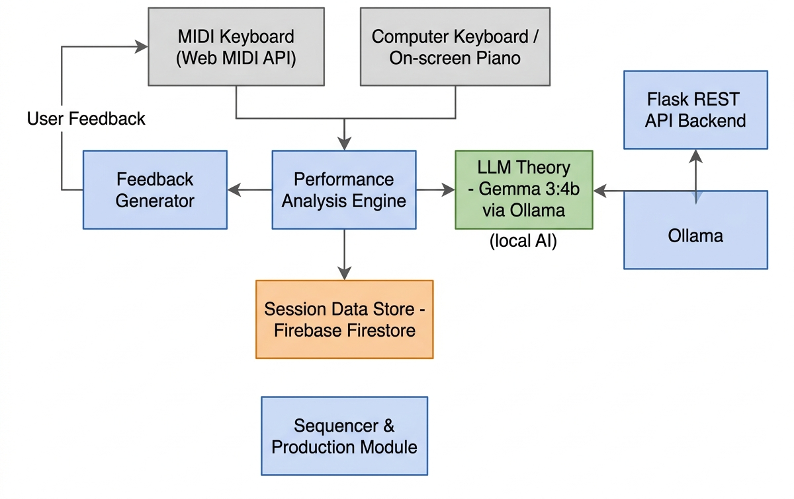
Figure 3.1: Proposed MIDISense Framework for Real-Time MIDI Analysis and Contextual AI Tutoring
In Figure 3.1, grey boxes are input devices, blue boxes are processing modules, the green box is the local language-model tutor and the orange box is the session data store. Notes from either input source reach the Performance Analysis Engine, which evaluates timing, note correctness and dynamics. Its result is passed to the Feedback Generator, whose message returns to the learner as user feedback, and to the LLM theory tutor, which is reached through the Flask back end and the local Ollama service. The same analysis, together with practice statistics and lesson progress, is kept in the session data store, and the sequencer and production module lets the learner continue from practice to composition. The figure therefore summarises the central idea of the project: one analysis of the learner’s own playing feeds both the immediate rule-based feedback and the contextual AI tutor.
The design also allows a microphone input as a secondary source for non-MIDI instruments. This input is only a design provision; it is not part of the prototype that was implemented and tested for this report.

3.4 Overall Workflow
The workflow of a practice session proceeds in the following order:
- The user signs in, and the lesson progress is loaded from Firebase Firestore and merged with the copy held in the browser.
- A new user takes the 20-question beginner assessment. A score of at least 17/20 passes and opens the production interface.
- The user opens a lesson or free practice and plays on the MIDI keyboard, the computer keyboard or the on-screen piano.
- Each note is captured with its velocity and start time, counted in the practice statistics, played back as sound and highlighted on the on-screen piano.
- When the sliding window of recent notes is complete, the analysis engine evaluates timing, note correctness (in lesson mode) and dynamics, and it generates rule-based feedback.
- The accuracy shown in the interface is updated, and the analysis object is sent to the Flask back end.
- The back end prompts Gemma 3:4b through Ollama, and the returned coaching message is shown to the learner and added to the tutor chat history.
- The learner can ask the tutor questions, complete the lesson to unlock the next one, or continue to the sequencer.

3.5 System Modules
Table 3.1 lists the main modules of the implementation and their responsibilities. Each module is described in detail in Chapter 4.
Module | Responsibility
MIDI input and event capture (PianoKeyboard) | Reads MIDI, computer-keyboard and mouse input; timestamps notes; drives the on-screen piano; triggers the analysis.
Practice state (usePracticeStore) | Holds MIDI status, tempo, recording and metronome controls, live statistics, tutor chat history and realtime tutor requests.
Performance analysis (analysis-engine) | Builds the reference beat grid; analyses timing, note correctness and dynamics; generates rule-based feedback.
Contextual AI tutor (Flask back end) | Exposes /health, /realtime and /ask; builds prompts and calls Gemma 3:4b through the Ollama generate endpoint.
Learning workflow (useLessonStore) | Stores completed lessons; unlocks lessons in sequence; synchronises progress with Firestore and local storage.
Sequencer and production access | Lets the learner record and develop musical ideas once the assessment has been passed.
User interface (React, Tailwind CSS) | Sign-in, assessment, lessons, practice and production pages.
Table 3.1: Major System Modules

3.6 Data Flow
Data moves through MIDISense in three stages. Raw MIDI messages are converted into note objects in the browser. The analysis engine turns windows of note objects into an analysis object, and the practice store turns that object into statistics and a tutor request. The back end converts the request into a prompt, and the model’s reply travels back to the practice store as a coaching message. Table 3.2 lists the data exchanged between the main modules.
From | To | Data
MIDI keyboard | Capture module | Status byte, note number and velocity of each MIDI message
Capture module | Analysis engine | Note objects: pitch, velocity, start time and end time
Analysis engine | Practice store | Analysis object: timing, note correctness, dynamics and feedback text
Practice store | Flask back end (/realtime) | The analysis object
Practice store | Flask back end (/ask) | The learner’s question, notes played, accuracy and session time
Flask back end | Ollama (Gemma 3:4b) | A prompt built from the analysis or from the question and statistics
Ollama | Flask back end, then practice store | A short coaching instruction or a short answer
Lesson store | Firestore and local storage | Identifiers of completed lessons
Table 3.2: Data Exchanged Between the Main Modules
The only interface between the browser and the language model is the Flask REST API. This keeps the model replaceable and keeps the analysis path independent of the tutor, so a failed tutor request never prevents notes from being captured and analysed.

3.7 Hardware Requirements
Table 3.3 lists the hardware on which the system was developed and tested, together with the configuration recommended for running the front end, the back end and the local language model at the same time.
Component | Tested configuration / requirement
Processor | 13th Gen Intel Core i5-13420H (Windows laptop); Apple M3 (MacBook)
RAM | 16 GB (Windows laptop); 8 GB (MacBook)
Graphics | NVIDIA GeForce RTX 3050 6 GB Laptop GPU (Windows laptop); integrated graphics on the MacBook
Storage | At least 10 GB of free space for the project dependencies and the language-model files
Operating system | Windows 10/11 and macOS (both used for development and testing)
Input device | USB MIDI keyboard or controller (Akai MPK Mini Play used for testing)
Display | Standard laptop or desktop display
Internet connection | Required for Firebase sign-in and lesson-progress synchronisation; not required for the local language model
Table 3.3: Hardware Configuration
A MIDI keyboard is required for hardware-based MIDI input; without it, the computer keyboard and the on-screen piano can be used. The 4-billion-parameter language model ran locally on both test machines, including the MacBook with 8 GB of RAM.

3.8 Software Requirements
Table 3.4 lists the software technologies used to build and run MIDISense.
Software / technology | Purpose
Windows 10/11 or macOS | Operating system
Python | Back-end development
Flask and Flask-CORS | Back-end REST API bridge between the interface and the language model; permits cross-origin requests from the front end
Python requests library | Calls the Ollama generate endpoint from the Flask back end
Node.js and npm | Front-end tooling
React.js | Front-end user interface
Vite | Front-end development server and build tool
JavaScript (JSX) | Client-side logic, MIDI event processing and the analysis engine
Tailwind CSS | Styling of the user interface
Zustand | State stores for practice statistics, lessons and authentication
Web MIDI API [27] | Receives MIDI events from the browser
Ollama with Gemma 3:4b [26], [28] | Runs the open-weight language model locally for the AI tutor
Firebase (Authentication and Firestore) | User sign-in and storage of lesson progress
Browser local storage | Local copy of completed lessons, used as a fallback
Visual Studio Code | Development environment
Git and GitHub | Version control and source-code management
Table 3.4: Software and Technologies

3.9 Non-Functional Requirements and Design Considerations
- Responsiveness: analysis runs in the browser every time a note is played, and requests to the language model are limited by a 2-second cooldown so that the tutor does not lag behind the player.
- Privacy: the language model runs on the user’s own computer through Ollama, and only note data, not audio, is analysed.
- Reliability: completed lessons are saved to local storage first and then to Firestore, so a failed network request does not lose progress.
- Usability: the on-screen piano and the computer keyboard allow practice without a MIDI device, and keyboard capture is disabled while the user types in a text field such as the tutor chat.
- Portability: the application runs in the browser on Windows and macOS.
- Maintainability: state is kept in separate stores for practice, lessons and authentication, and the analysis engine is a separate module.
- Cost: the stack uses open-source tools and an open-weight model, so there is no per-request language-model cost.

3.10 Summary
This chapter described the existing and proposed systems, the architecture, workflow, modules and data flow of MIDISense, and the hardware and software it needs. The design keeps input capture, analysis and tutoring separate and connects them through well-defined data objects and one REST interface. The next chapter explains how each stage was implemented.

CHAPTER 4
IMPLEMENTATION AND METHODOLOGY

4.1 Development Approach and Infrastructure
The work is applied and experimental. Development followed an iterative, Agile-style model with short cycles of requirement analysis, prototype design, module development and testing, system integration and functional validation. Each stage was verified on real hardware before the next was added, which exposed several integration problems that were corrected during development (Section 5.4 and Section 6.1).
The React front end runs the capture, analysis and interface logic in the browser. The Flask back end exposes the endpoints through which the front end reaches the language model, and Ollama serves the model locally. For deployment on a development machine, three processes are started: the Ollama service, which listens on port 11434, the Flask back end on port 8000 and the Vite front-end server. The application is then opened in the browser at localhost on port 5173.

4.2 Reference Material and Data
MIDISense does not rely on a pre-collected dataset. The reference material consists of the lesson definitions, which contain the target notes of each exercise and are held in the lessons data module of the application. In free practice there is no target sequence, so only timing and dynamics are analysed, over a rolling group of five notes. All performance data come from live input.
For every note, the application records the MIDI note number, the velocity (limited to the range 1–127), the start time and, for MIDI input, the end time. The start time is taken from the browser’s high-resolution clock, performance.now(), which gives sub-millisecond resolution and is not affected by changes to the system clock.

4.3 MIDI Input and Event Capture
This module is the foundation of the system and is implemented in the PianoKeyboard component. It converts raw input messages into timestamped note events. The Web MIDI API (navigator.requestMIDIAccess) [27] gives a web page direct access to the MIDI devices connected to the computer, so no plug-in or driver-level software is needed beyond a Chromium-based browser.
- Access and listening: the application requests MIDI access and attaches a message handler to every connected input. A state-change handler re-attaches the handler and updates the connection status when a device is plugged in or removed.
- Message decoding: the status byte is masked to identify note-on (0x90) and note-off (0x80, or note-on with velocity 0) messages. Duplicate note-on messages for a note that is already sounding are ignored.
- Timestamping and capture: each note-on is stamped with performance.now() and stored with its velocity; the matching note-off adds the end time.
- Alternative inputs: the home-row keys A to the apostrophe key play the notes C4 to F5, and the on-screen piano, which spans C3 to B6, can be played with the mouse. Keyboard capture is disabled while the user is typing in an input field, and repeated key events caused by holding a key down are ignored.
- Audio and highlighting: each note triggers the piano sound and highlights the key; the expected note of a lesson is highlighted in yellow.
Computer-keyboard and mouse input use a fixed velocity of 100, so dynamics analysis is only meaningful for a MIDI keyboard. The output of the module is a time-ordered list of note events with pitch, start time, end time and velocity. Table 4.1 summarises the three input sources.
Input source | Event mechanism | Velocity | Note range
MIDI keyboard | Web MIDI API note-on / note-off messages | Measured (1–127) | Any note sent by the device
Computer keyboard | keydown / keyup events | Fixed at 100 | C4 to F5 (home-row keys)
On-screen piano | Mouse down / up events | Fixed at 100 | C3 to B6
Table 4.1: Input Sources Supported by MIDISense

4.4 Practice State and Statistics
The practice store (usePracticeStore, a Zustand store) holds the state shared by the practice page. It contains the MIDI connection status and device name, the recording, metronome and tempo controls (the tempo is limited to 20–300 BPM and is saved), the active keys and expected note of the on-screen piano, the toast notifications, the tutor chat history and the live performance statistics.
The statistics are the number of notes played, the accuracy and the session time. The first note played starts the practice session, every note increments the notes-played counter, the accuracy is rounded and limited to the range 0–100, and the session time is calculated in seconds from the start of the session. The chat history and the tempo are loaded and saved through the practice service so that they persist between visits.

4.5 Performance Analysis: Timing Accuracy
The analysis engine runs every time a note is played, as soon as the window of recent notes is complete. It works on a sliding window. In lesson mode the window length equals the number of target notes of the lesson; in free practice it is a rolling group of five notes. After each analysis the oldest note is dropped and the others are kept, so that the next note completes a new window.
Timing is judged against a reference beat grid. The grid is built from the start time of the first note in the window at a tempo of 120 BPM, which gives a spacing of 60 000 / 120 = 500 ms between beats, and it contains as many beats as there are notes in the window. Each played note is compared with the closest beat of the grid, and its timing deviation is
Δ_{i} = t_{i} − g_{k(i)} (1)
Equation (1) measures how early or late the i-th note is. Here t_{i} is the start time of the note in milliseconds, and g_{k(i)} is the grid beat that lies nearest to it, so a positive Δ_{i} means that the note was late and a negative value means that it was early. MIDISense uses this value both for the on-time decision in Equation (2) and for the “milliseconds behind or ahead of the beat” wording of the feedback.
A note is classed as on time when the absolute deviation does not exceed 40 ms:
on_time_{i} = ( |Δ_{i}| ≤ 40 ms ) (2)
Equation (2) is a threshold test that returns true when the note falls inside a ±40 ms tolerance band around its grid beat. The tolerance is needed because human playing is never perfectly regular, and a fixed band separates natural expressive variation from a genuine timing error. The value of 40 ms is a fixed design choice of MIDISense and is not tuned to the individual player.
The timing accuracy of a window is the proportion of notes classed as on time. The practice store receives it as a percentage:
Accuracy_{timing} = ( N_{on-time} / N ) × 100 (3)
Equation (3) turns the individual on-time decisions into one score for the window, where N_{on-time} is the number of notes for which Equation (2) is true and N is the number of notes in the window. In free practice this percentage is the accuracy displayed to the learner. Because the grid starts at the first note of the window, that note always has zero deviation, and with a five-note window the timing accuracy can only take the values 20, 40, 60, 80 or 100%.
The feedback generator then converts the timing result into a short message using fixed rules. If 70% or more of the notes are on time, the message is positive. Otherwise, the message states the average number of milliseconds by which the late notes are behind the beat, or by which the early notes are ahead of it, and it suggests a remedy such as counting aloud or slowing down.
The reference grid has two simplifications that should be kept in mind when interpreting the timing accuracy. The tempo is fixed at 120 BPM and is not linked to the tempo setting of the practice page, and the grid starts at the first note of the window, so the measure judges the steadiness of the spacing between notes more than agreement with an external tempo.

4.6 Performance Analysis: Note Correctness
Note correctness is analysed in lesson mode only, because only a lesson defines a target melody. The analysis compares the i-th played note of the window with the i-th target note and divides the number of matches by the smaller of the two lengths, which is the length of the window when the window equals the length of the target. The per-note result records the expected note, the played note and whether they are equal.
In addition, the PianoKeyboard component counts every note played while a lesson note is expected as an attempt, and it counts the attempt as correct when the note equals the expected note:
Accuracy_{lesson} = ( N_{correct} / N_{attempts} ) × 100 (4)
Equation (4) gives a running accuracy for the current lesson, where N_{correct} is the number of notes that matched the expected note and N_{attempts} is the number of notes played so far in the lesson. It lets the learner see the effect of each wrong key immediately, and the two counters are reset whenever the lesson target changes. The running value is shown as the accuracy until the first full window of notes has been played, after which the window-based result above also updates the display.
The feedback generator reports the note-correctness result as “all notes correct” when the accuracy is 100%, as good with a few slips when it is 70% or more, and otherwise as accuracy that needs more practice, with the suggestion to slow down and repeat the phrase.

4.7 Performance Analysis: Dynamics and Feedback Generation
Dynamics are evaluated from the MIDI velocities of the notes in the window. The engine calculates the average velocity and the variance of the velocities, and it classes the playing as flat when the variance is below 15. A flat result means that every note was struck with almost the same force, and the feedback then suggests varying the touch for a more expressive sound. The average velocity is also reported. In the captured screens (Section 5.5) the interface additionally shows a dynamic label such as mezzo-forte or forte beside the velocity of the latest note; that labelling is visible in the screenshots but is not part of the analysis-engine code reproduced in Chapter 9.
The feedback generator combines the three results into short text messages. The rules are summarised in Table 4.2, and the three results together with the messages form the combined analysis object that is passed on to the tutor.
Analysis result | Condition | Message produced
Timing | 70% or more of notes on time | Positive message giving the percentage of notes close to the beat
Timing | Below 70% and late notes are at least as many as early notes | States the average milliseconds behind the beat and suggests counting aloud
Timing | Below 70% and early notes dominate | States the average milliseconds ahead of the beat and suggests slowing down
Note correctness | Accuracy equal to 100% | All notes were correct
Note correctness | Accuracy from 70% to below 100% | Note accuracy is good, with a few slips
Note correctness | Accuracy below 70% | Suggests slowing down and practising the phrase again
Dynamics | Velocity variance below 15 | Dynamics are flat; suggests varying how hard the keys are pressed
Table 4.2: Rule-Based Feedback Generated from the Analysis

4.8 Contextual AI Tutor: Flask Backend and Ollama with Gemma 3:4b
This module turns the analysis into helpful teaching. It consists of the tutor functions of the practice store in the front end and a small Flask service in the back end, which calls the Gemma 3:4b model [26] through the generate endpoint of the local Ollama server [28] in non-streaming mode. Gemma 3:4b is an open-weight model with about four billion parameters, small enough to run on both test laptops. The model is not retrained; it is guided only by the prompt and the supplied context, in the manner of prompt-based use of language models [23]. The Flask service has cross-origin access enabled so that the browser application can call it, and it exposes the three endpoints listed in Table 4.3.
Endpoint | Input | Output | Behaviour
GET /health | None | Status “ok” | Lets the interface check that the service is running
POST /realtime | The analysis object (timing, note correctness, dynamics, feedback) | One short coaching instruction | Prompt asks for exactly one specific, encouraging instruction of at most 12 words; 30-second timeout; HTTP 503 if Ollama is unavailable
POST /ask | The learner’s question and the session data (notes played, accuracy, session time) | A short answer | Prompt asks for two to four short sentences in plain language that use the session data; empty questions are rejected; 60-second timeout
Table 4.3: Endpoints of the Flask Tutor Service
After each analysis, the practice store calls requestRealtimeFeedback. Calls closer than 2 seconds to the previous one are ignored, so a fast passage does not flood the model with requests. A valid reply is added to the chat history as a tutor message and is shown in the interface. In the chat, the learner’s message is added to the history, the question is sent together with the current practice statistics, and the answer is appended. If the service cannot be reached, the tutor shows a message asking the user to make sure that the tutor server and Ollama are running.
The /ask prompt tells the model that it is a friendly, concise music-theory tutor in a practice app, supplies the notes played, the accuracy and the session time, and asks it to refer to this information instead of giving a generic textbook answer. This grounding is what makes the tutor contextual. The tutor’s role is to explain the reason for a mistake, to name the music-theory idea behind it and to suggest what to try next.

4.9 Learning Workflow: Assessment and Lesson Progression
The learning workflow controls what the learner can do next. A beginner assessment contains 20 questions and has a pass mark of 17/20 (85%). A learner who scores below the pass mark may retry. Passing the assessment opens the production interface. Lessons are unlocked in sequence, so that a learner works through the material in order. The lesson store (useLessonStore) keeps the set of completed lesson identifiers and offers the functions listed in Table 4.4.
Function | Purpose
fetchProgress | Loads the progress from Firestore and merges it with the progress held in local storage
completeLesson | Adds the lesson to the state, saves it to local storage first and then to Firestore; if the Firestore write fails, the local completion is kept
isCompleted and isUnlocked | A lesson is unlocked when it is the first lesson or when the previous lesson has been completed, using local storage as a fallback
resetProgress | Clears the stored progress
Table 4.4: Functions of the Lesson Store
Saving to the browser first and to Firestore second makes the workflow tolerant of network failures. Storage in Firestore was confirmed to work after the corresponding Firebase security rules were updated (Section 5.2).

4.10 Sequencer and Music Production Access
Once the assessment has been passed, the learner can open the production area of the application. The built-in sequencer allows the learner to record playing and to develop it into a sequence, and it offers lightweight, rule-based accompaniment suggestions. This module is a starting point for the connection between practice and production and not a replacement for a full DAW. Its use was verified functionally (Table 5.1), but its usefulness for creative work has not yet been evaluated.

4.11 User Interface
The interface is built with React and styled with Tailwind CSS. Its main pages are the sign-in and sign-up page with Firebase-based authentication, the assessment page with the result and retry option, the lessons page with locked and unlocked lessons, the practice page and the production page that contains the sequencer. Figure 4.1 shows the practice page.
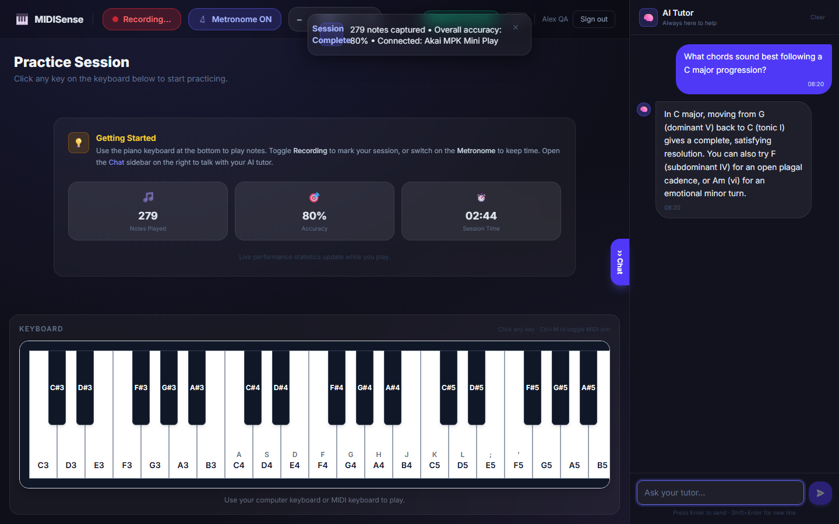
Figure 4.1: MIDISense User Interface
The practice page in Figure 4.1 has three regions. The main region contains the three live statistics cards for notes played, accuracy and session time, and below them the on-screen piano, which spans C3 to B6 and shows the computer-keyboard shortcut on the keys that have one. The top bar contains the recording and metronome controls, the tempo control, the MIDI connection status and a toast area in which session messages appear. The right-hand AI Tutor panel shows the chat history, the input box for questions and the tutor’s answers. In this capture the statistics show 279 notes, an accuracy of 80% and a session time of 02:44, and the tutor panel shows an answer to a question about chord progressions in C major. The page therefore brings capture, analysis and tutoring together on one screen, which is the main usability goal of MIDISense.

4.12 Execution Flow
At run time, the components described above cooperate as follows. A note arrives from the MIDI keyboard, the computer keyboard or the mouse and is captured, timestamped, counted, played back and highlighted. When the window is complete, the analysis engine evaluates it, updates the accuracy and produces the feedback. The analysis object is then sent to the Flask back end, which prompts the local language model and returns a short coaching message to the practice store and the interface. In parallel, the learner can ask the tutor questions, complete the lesson to unlock the next one, or continue to the sequencer. The numbered workflow in Section 3.4 gives the same sequence from the learner’s point of view.

4.13 Testing and Validation Approach
- MIDI capture verification: the Akai MPK Mini Play was used to verify that note-on and note-off events, velocity and timestamps are captured correctly.
- Analysis-engine validation: the timing, note-correctness and dynamics routines were validated with an automated test suite before hardware testing.
- Live-session testing: live playing on a connected MIDI keyboard exposed problems that the automated tests had not (Section 5.4), and these were corrected.
- Functional testing: login and sign-up, the assessment, lesson unlocking, Firestore progress storage, the tutor and the production access were each exercised end to end.
- Representative session: one integrated practice session was recorded to confirm continuous capture, analysis, statistics and tutoring.
MIDISense processes only note data, not voice or audio, so very little personal information is involved. The language model runs locally, so performance summaries are not sent to an external language-model provider. Lesson progress is stored in the user’s Firebase account and in the browser’s local storage. Because the participant evaluation has not yet been carried out, no data from other people were collected for this report.

4.14 Design Rationale
- MIDI instead of audio: removes the transcription step, so feedback is exact and immediate.
- Browser-based: the Web MIDI API lets the whole practice experience run in the browser with no installation of audio software.
- Local language model: keeps performance data on the user’s computer and avoids per-request costs.
- Shared accuracy calculation: live testing showed that the displayed accuracy and the written timing feedback could disagree, so both were made to use the same calculation.
- Local-first progress storage: the lesson store saves to the browser first, so progress survives a network failure.

4.15 Summary
This chapter described the implementation of MIDISense: MIDI capture through the Web MIDI API, the practice store, the timing, note-correctness and dynamics analysis with Equations (1) to (4), the Flask back end and the Gemma 3:4b tutor under Ollama, the learning workflow, the sequencer and the user interface. The next chapter reports the results obtained when the system was tested.

CHAPTER 5
RESULTS AND DISCUSSION

5.1 Experimental Setup
The prototype was tested to verify its MIDI connectivity, real-time performance analysis, AI feedback and learning workflow. All results in this chapter come from the testing carried out during development; no figures have been estimated. The tests used an Akai MPK Mini Play USB MIDI keyboard connected to a Windows laptop (Intel Core i5-13420H, 16 GB RAM, NVIDIA RTX 3050 6 GB) and to a MacBook (Apple M3, 8 GB RAM), as listed in Table 3.3. The tutor ran locally through Ollama with Gemma 3:4b on both machines, and the application was used in a Chromium-based browser. The representative practice session reported in Section 5.5 was recorded on the MacBook.

5.2 Functional Testing Results
Table 5.1 summarises the functional tests. Each feature was exercised end to end, from user action to visible result.
Feature | Observed result
User sign-up and login | Successful
Beginner assessment | Successful (20 questions)
Assessment scoring | Tested with 16/20 (not passed) and 17/20 (passed)
Lesson progression | Lesson 1 completed and Lesson 2 unlocked
Firestore progress storage | Working after the security rules were updated
MIDI keyboard connection | Connected
Real-time note detection | Successful
On-screen piano and computer-keyboard input | Successful
Timing analysis | Working
Note-accuracy analysis | Working
Dynamics analysis | Working
AI tutor | Real-time feedback received
Ollama with Gemma 3:4b | Working
Music production access | Working
Table 5.1: Summary of Functional Tests
All fourteen checks gave the expected result. These are functional checks and show that the features operate as designed; they are not measurements of learning benefit.

5.3 MIDI Capture Verification
MIDI capture was verified with an Akai MPK Mini Play. The device was detected reliably, note-on and note-off events were decoded correctly, velocity values were preserved across soft and loud playing, and millisecond timestamps were recorded for every event. The captured events provide the timing resolution that the analysis engine requires for the 40 ms tolerance of Equation (2).

5.4 Analysis Engine Validation and the Feedback Inconsistency
The timing, note-correctness and dynamics routines were validated with an automated test suite before hardware testing. Live playing on the connected keyboard then revealed two problems that the tests had not shown. First, the numerical timing accuracy displayed to the user and the natural-language timing feedback were produced by different logic and could disagree for the same performance. The feedback logic was corrected so that both use the same accuracy calculation, Equation (3). Second, the number of notes played increased while the displayed accuracy remained at 100%. The connection between the analysis result and the accuracy update in the practice store was corrected, and the accuracy was redefined for free practice so that arbitrary playing is not compared with a fixed melody. These cases show the value of testing with real hardware and real playing in addition to automated tests.

5.5 Integrated Practice Session
The integrated practice interface was evaluated with a connected MIDI keyboard to verify continuous MIDI capture, performance analysis, practice statistics and real-time AI tutoring. Table 5.2 gives the values recorded in one representative free-practice session.
Measure | Observed value
Machine | MacBook (Apple M3, 8 GB RAM)
Mode | Free practice
MIDI notes captured | 279
Session duration | 2 minutes 44 seconds (02:44)
Reported accuracy | 80%, the timing accuracy shown by the interface: the proportion of notes within 40 ms of the nearest beat of a 120 BPM reference grid, calculated over the most recent five-note window
MIDI device status | Connected throughout the session
AI tutor | Active; real-time coaching feedback generated
Table 5.2: Representative Practice Session
The figures come from a single session and are intended to demonstrate that the pipeline operates; they do not measure learning outcomes. The accuracy value is the one displayed at the end of the session. It describes the latest five-note window and not an average over all 279 notes, and with five notes it can only take steps of 20%, so 80% corresponds to four of the five most recent notes being on time. Dividing the notes by the session length gives about 1.7 notes per second on average, a value derived from Table 5.2 and not measured separately.
Figures 5.1 to 5.6 are screenshots of the running application. Table 5.3 lists the values that are visible in them. The note counts and session times increase from one capture to the next, which is consistent with a single continuous session, although the screenshots do not state this.

Figure | Notes played | Accuracy | Session time | Message or panel shown
Figure 5.1 | 42 | 85% | 00:48 | Toast for C4: timing +6 ms (on beat), velocity 84 (mezzo-forte)
Figure 5.2 | 118 | 82% | 01:32 | Toast for G4: timing −22 ms (slight rush), velocity 108 (forte)
Figure 5.3 | 118 | 82% | 01:32 | Tutor chat answer about steady rhythm
Figure 5.4 | 279 | 80% | 02:44 | Tutor message list with repeated coaching messages
Figure 5.5 | 185 | 82% | 01:52 | Toast for a detected C–E–G chord; tutor chat answer
Figure 5.6 | 279 | 80% | 02:44 | Session-complete toast; tutor chat answer
Table 5.3: Values Visible in the Captured Screenshots

5.5.1 MIDI Performance Analysis Output
Figures 5.1 and 5.2 show the analysis output while the learner is playing. The toast at the top of the page is generated after each analysis and reports the timing deviation of the latest note and its velocity.

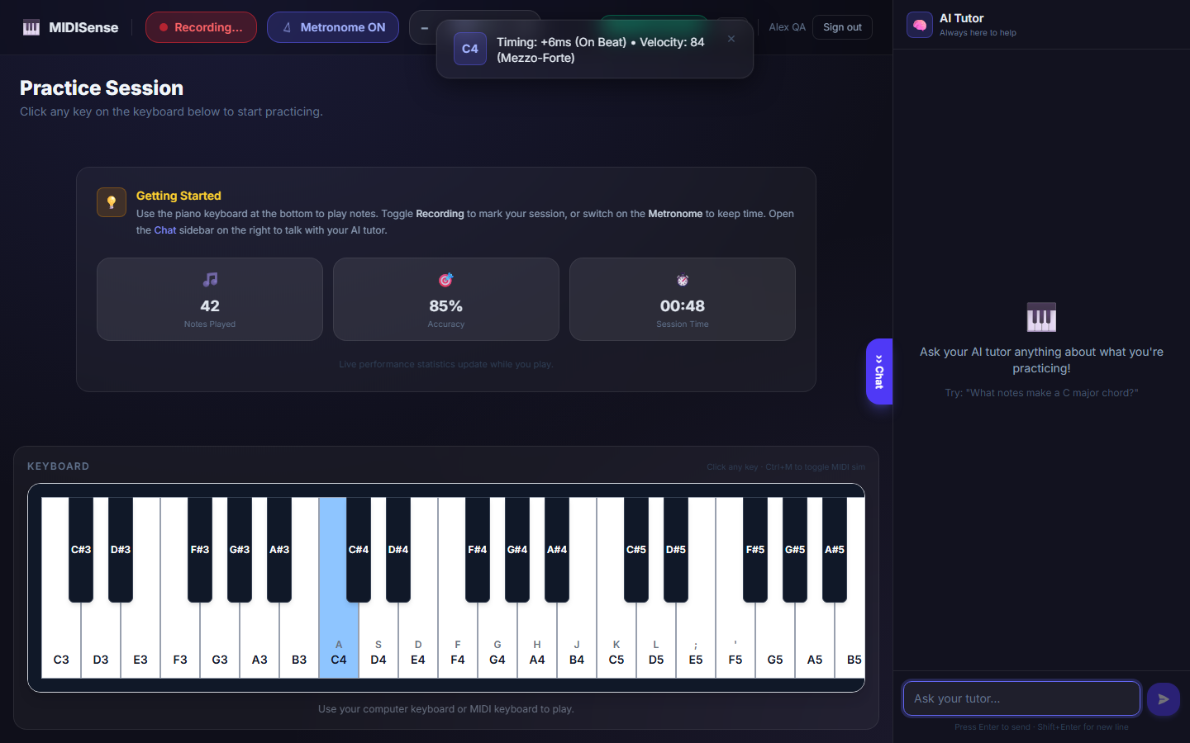
Figure 5.1: MIDI Performance Analysis Output (i)
In Figure 5.1 the learner has just played C4, which is highlighted in blue on the on-screen piano. The toast reports a timing deviation of +6 ms, labelled “On Beat”, and a velocity of 84, labelled “Mezzo-Forte”. A deviation of 6 ms lies well inside the 40 ms tolerance of Equation (2), so the note counts as on time. The three statistics cards show 42 notes, 85% accuracy and a session time of 00:48, and the tutor panel is still empty because no question has been asked. The figure demonstrates the chain from a captured MIDI note to a numerical timing and dynamics result that is shown immediately.

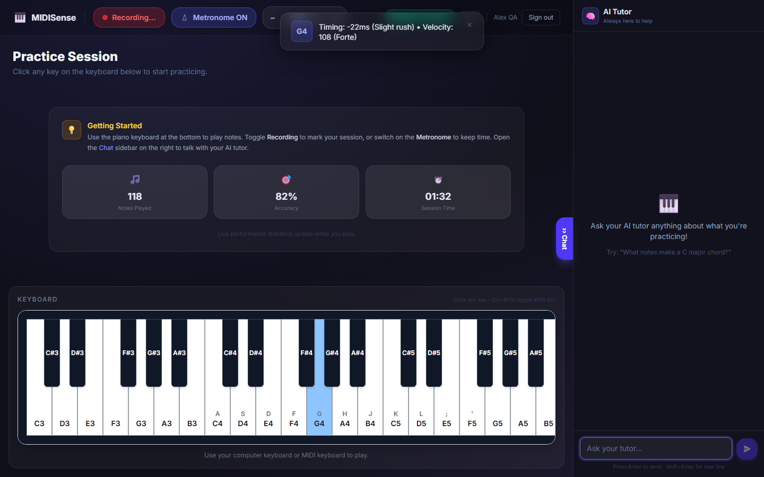
Figure 5.2: MIDI Performance Analysis Output (ii)
Figure 5.2 shows a later point of the practice session, with 118 notes, 82% accuracy and a session time of 01:32. The latest note, G4, is highlighted, and the toast reports a deviation of −22 ms, labelled “Slight rush”, with a velocity of 108, labelled “Forte”. The negative sign means that the note arrived before its grid beat, as defined in Equation (1), and its magnitude is still below the 40 ms tolerance. Comparing Figures 5.1 and 5.2 shows that the analysis follows changes in both timing direction and playing strength from note to note.
5.5.2 AI Tutor Feedback
Figures 5.3 and 5.4 show the two ways in which the tutor responds: a chat answer to a learner’s question and automatic coaching messages after each analysis.

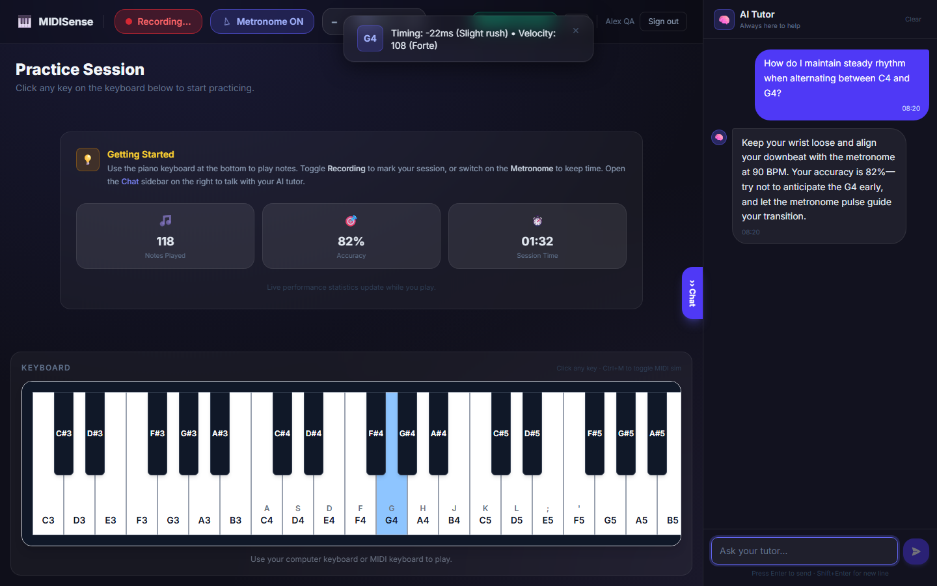
Figure 5.3: AI Tutor Feedback Sample (i)
In Figure 5.3 the learner asked how to maintain a steady rhythm when alternating between C4 and G4. The tutor answered with advice to keep the wrist loose, to align the downbeat with the metronome and not to anticipate the G4 early, and the answer quotes the current accuracy of 82%. This shows that the /ask endpoint passes the practice statistics to the model and that the answer refers to the learner’s own data and not to a generic textbook explanation. The question and the answer carry time stamps, and the chat history persists in the right-hand AI Tutor panel.

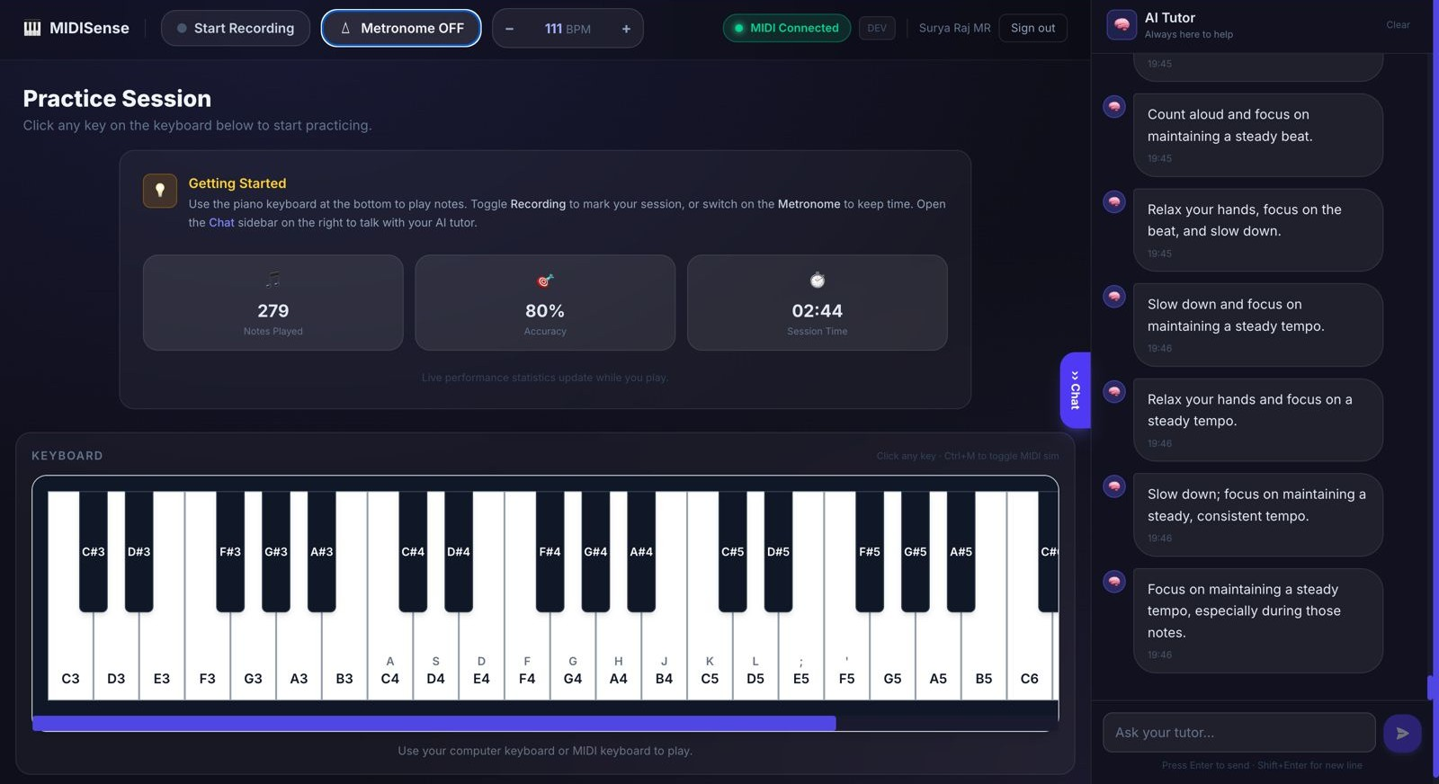
Figure 5.4: AI Tutor Feedback Sample (ii)
Figure 5.4 shows the list of automatic coaching messages produced by the /realtime endpoint during the 279-note session. Each message is a single short instruction, such as to count aloud, to relax the hands or to slow down and keep a steady tempo, which matches the prompt rule of one instruction of at most 12 words. The figure also shows a limitation of the small local model: the messages are similar to each other and repeat the same advice about a steady tempo. The tutor therefore responds in real time, but the variety and depth of its automatic messages were not measured in this project.
5.5.3 Live MIDI Keyboard Session
Figures 5.5 and 5.6 show the live session on the connected MIDI keyboard at two later points.

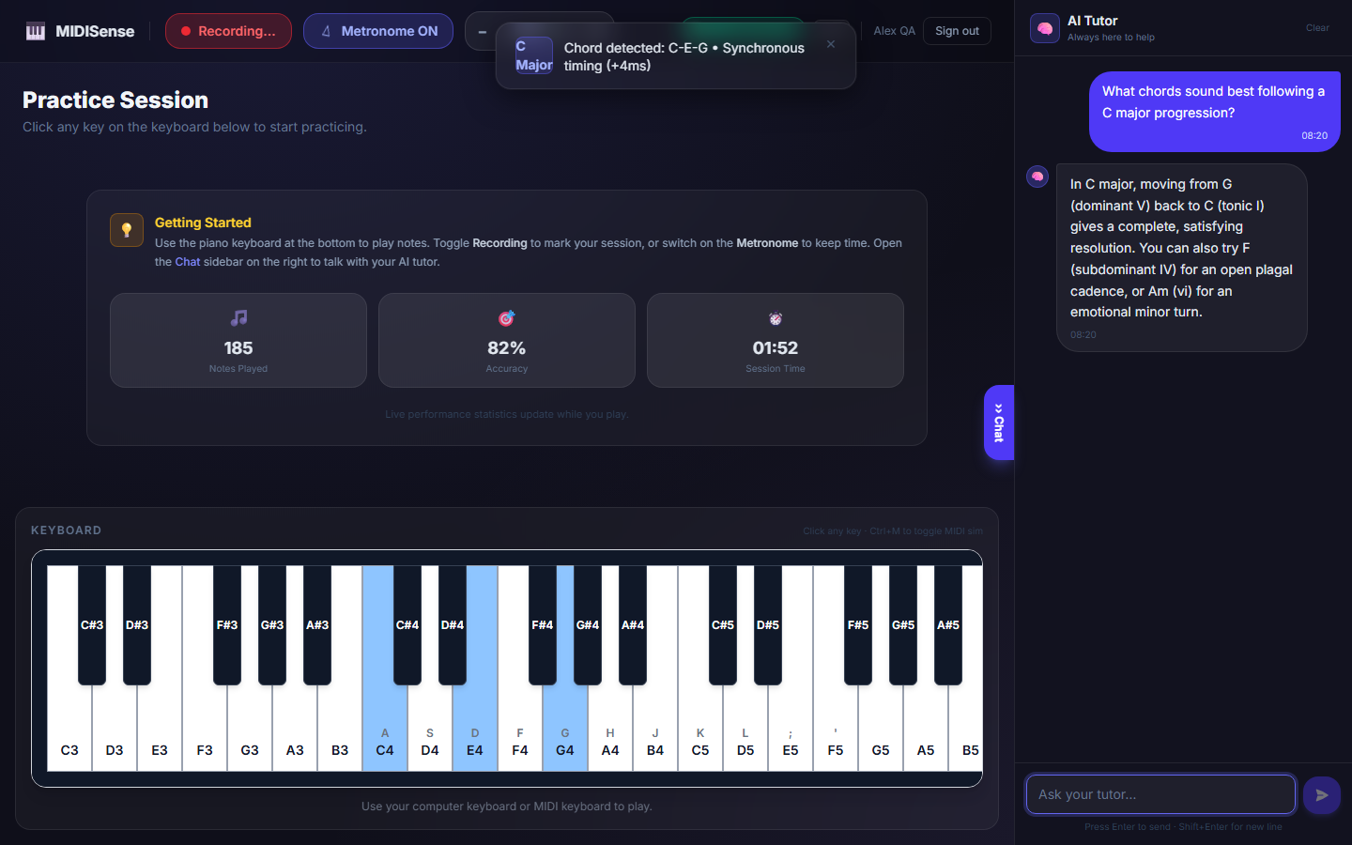
Figure 5.5: Live MIDI Keyboard Session (i)
In Figure 5.5 several keys are highlighted at the same time, because the learner is holding a chord on the MIDI keyboard. The toast reports “Chord detected: C-E-G” with a synchronous timing of +4 ms, and the statistics cards show 185 notes, 82% accuracy and 01:52. The AI Tutor panel shows a question about chords that follow a C major progression and the tutor’s answer, which names the dominant (G) to tonic (C) resolution and the F and A minor alternatives. The chord label is visible in the captured interface but is not described in the analysis-engine code reproduced in this report, so it is mentioned here only as an observed output of the application.

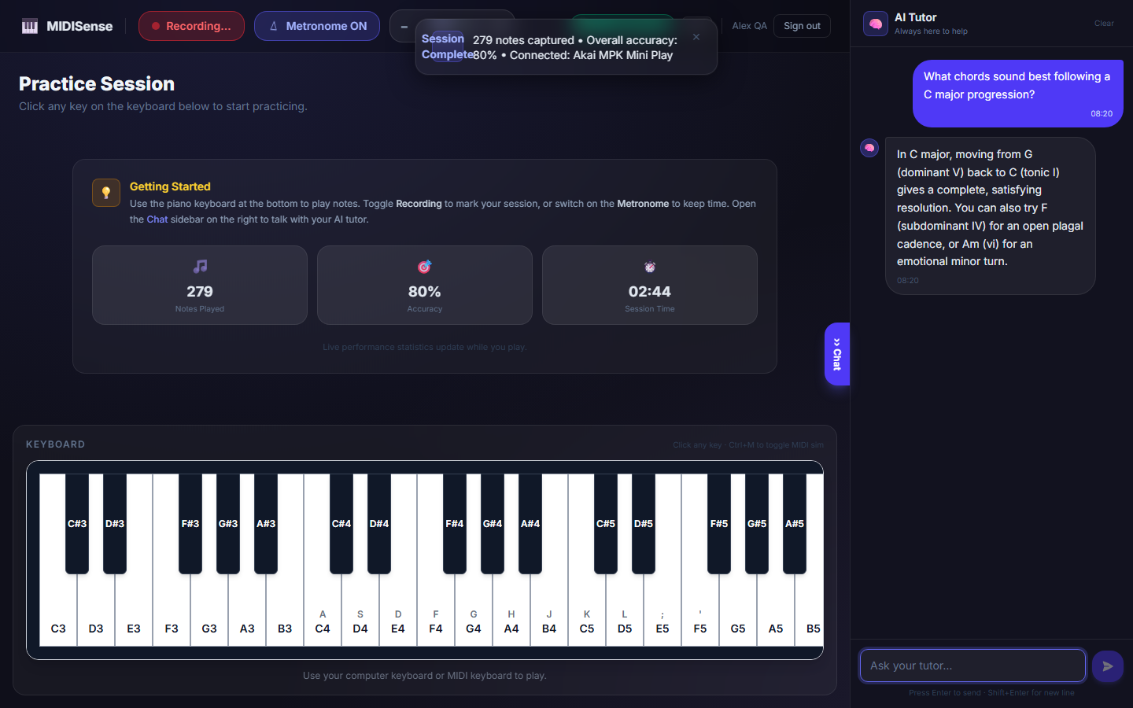
Figure 5.6: Live MIDI Keyboard Session (ii)
Figure 5.6 shows the end of the representative session. The “Session Complete” toast reports 279 notes captured, an overall accuracy of 80% and the connected device, Akai MPK Mini Play, and the statistics cards show 279 notes, 80% and 02:44, the values given in Table 5.2. The figure confirms that MIDI capture, counting, accuracy reporting and the tutor panel stayed active together for the whole session on real hardware.

5.6 Learning Workflow and Assessment
The learning workflow was verified through the beginner assessment and the lesson progression. The assessment consists of 20 questions with a pass mark of 17/20 (85%). Table 5.4 shows the two attempts recorded during testing. Lesson progression was verified by completing Lesson 1, which unlocked Lesson 2. Storage of lesson progress in Firebase Firestore was confirmed after the corresponding security rules were updated.
Attempt | Score | Outcome
1 | 16/20 (80%) | Not passed; retry allowed
2 | 17/20 (85%) | Passed; production interface unlocked
Table 5.4: Assessment Attempts Recorded During Testing
These two attempts show that the pass mark is enforced exactly: a score of 16/20 was not accepted, and a score of 17/20 passed and unlocked the production interface.

5.7 Comparison with Existing Tools
MIDISense is compared with existing tools in Table 2.1 and Figure 2.1. The comparison is based on the capabilities that each approach offers, because the tools use different data and different measures and no head-to-head experiment was run in this project. The practical differences are that MIDISense works on exact MIDI data without transcription, gives feedback while the learner is still playing, grounds a language-model tutor in the learner’s own performance, and keeps the model on the learner’s computer. Its limits are equally clear: it needs a MIDI instrument for dynamics analysis, its tutor is a small model, and its benefit to learners has not yet been measured.

5.8 Overall Discussion
The results confirm functional correctness and successful integration. MIDI events are captured, analysed and counted, the accuracy and statistics update, the tutor responds in real time, and the learning workflow gates access as designed. The screenshots show that the system produces concrete, per-note information (timing deviation in milliseconds, velocity and chord labels) and tutor text that refers to the learner’s statistics.
The results do not show that MIDISense improves learning. No controlled study has been carried out, the practice-session figures come from one session on one machine, and neither the tutor’s response latency nor the quality of its explanations was measured. The fixed 120 BPM grid and the five-note window also limit what the timing accuracy can say about a longer musical phrase. These questions belong to the planned participant evaluation described in Chapter 6.

5.9 Summary
This chapter reported the functional tests, the MIDI capture verification, the correction of the feedback inconsistency, the representative practice session with six application screenshots, and the assessment and lesson tests. It also stated what the results do not show. The next chapter concludes the report and outlines future work.

CHAPTER 6
CONCLUSION AND FUTURE WORK

6.1 Conclusion
The project “MIDISense: Real-Time MIDI Performance Analysis and Contextual AI Tutoring for Bridging Music Learning and Production” was developed to close the gap between learning an instrument and producing music. Learning platforms test skills and DAWs support production, but neither explains a learner’s mistakes or guides the transition between the two. MIDISense addresses this by analysing the MIDI stream directly in the browser and passing a structured summary of the performance to a contextual language-model tutor.
The main achievements of the project are the real-time capture of MIDI note-on and note-off events with velocity and millisecond timestamps; an analysis engine that evaluates timing against a 120 BPM reference grid with a 40 ms tolerance, note correctness against lesson targets and dynamics from velocities; a contextual tutor that runs locally (Gemma 3:4b through Ollama) and answers with reference to the learner’s statistics; a learning workflow with a 20-question assessment (pass mark 17/20), sequential lessons and progress stored in Firestore with a local fallback; a built-in sequencer opened after the assessment is passed; and live practice statistics in the interface.
Working on MIDI instead of audio removes the transcription step, so feedback can be more exact and can arrive sooner. Giving the learner’s actual performance data to the language model turns a general-purpose model into a personalised tutor, and running that model locally keeps the data on the learner’s computer. Placing assessment, lessons, practice, tutoring and sequencing in one application gives learners a single path from practising to making their own music, and it can lower the cost of personalised teaching for people without a private teacher. The system processes only note data, and it is intended to support human teachers and not to replace them.
Several challenges were met during development. The displayed timing accuracy and the written feedback disagreed until both used the same calculation. The accuracy display did not update until the connection between the analysis result and the practice store was corrected. Lesson progress was saved to Firestore only after the security rules were updated. Requests to the language model had to be rate-limited with a cooldown so that the analysis path stays responsive, and the 40 ms tolerance had to be chosen as a fixed value that separates natural expressive timing from genuine errors.
Table 6.1 separates what was implemented and tested from what was only designed or is planned.
Feature | Status | Evidence in this report
MIDI capture, on-screen piano and computer-keyboard input | Implemented and tested | Table 5.1; Section 5.3
Timing, note-correctness and dynamics analysis | Implemented and tested functionally | Table 5.1; Figures 5.1 and 5.2
Contextual AI tutor (Flask, Ollama, Gemma 3:4b) | Implemented and tested functionally; response latency and quality not measured | Table 5.1; Figures 5.3 and 5.4
Assessment, lessons and Firestore progress | Implemented and tested | Table 5.1; Table 5.4
Practice statistics | Implemented and tested | Table 5.2; Figure 5.6
Sequencer and production access | Implemented; access tested, usefulness not evaluated | Table 5.1
Microphone (audio) input for non-MIDI instruments | Design provision only; not implemented in the tested prototype | Section 3.3
Participant-based evaluation of learning outcomes | Planned | Section 6.3
Table 6.1: Implementation Status of MIDISense Features

6.2 Limitations
- The test results come from functional testing and one representative session on one machine; they do not show that learners improve.
- No formal participant study has been carried out.
- Tutor response latency and the quality of the explanations were not measured, and the small local model produces similar automatic messages repeatedly.
- MIDI does not capture tone quality, so the system cannot judge the timbre of an acoustic instrument.
- The reference grid uses a fixed tempo of 120 BPM and a short sliding window of notes, and it is not linked to the tempo setting of the practice page.
- The tutor is a small 4-billion-parameter local model whose explanations are less fluent than those of a much larger hosted model.
- The production side is lightweight and has not yet been evaluated for usefulness in creative work.
- The current version supports a single learner per session.

6.3 Future Scope
- Evaluation studies: conduct a participant-based study comparing learners who use MIDISense with learners who use conventional practice, measuring timing and note-accuracy improvement and the usefulness of the feedback, and measure tutor latency and response quality.
- Audio input support: add an audio-to-MIDI front end, using models such as Onsets and Frames [8], so that guitarists, vocalists and acoustic piano players can use the system without a MIDI instrument.
- Direct DAW integration: connect MIDISense to external DAWs through virtual MIDI ports or plug-in formats.
- Richer performance modelling: use sequence models such as Transformer-based symbolic music models [21] to learn expressive norms for phrasing and dynamics.
- Adaptive learning paths: keep a long-term learner profile with progress, recurring errors and goals, and build a personalised curriculum from it.
- Retrieval-augmented tutoring: ground the tutor’s explanations in a curated music-theory knowledge base using retrieval-augmented generation [25].
- Advanced production assistance and accompaniment: genre-aware suggestions for chord progressions, bass lines, drum patterns and arrangement, and automatic accompaniment that follows the learner’s tempo using score-following methods [5].
- Tempo-aware analysis: replace the fixed 120 BPM grid with a tempo chosen by the learner or detected from the playing.
- Deployment hardening: run the tutor service with debug mode off, restrict cross-origin access to the application’s own address and add authentication to the tutor endpoints before any shared deployment.
- Mobile and classroom tools: mobile applications and dashboards that summarise practice for teachers and schools, with engagement and accessibility features such as challenges, multiple languages and voice responses.

6.4 Summary
This chapter concluded that combining MIDI performance analysis with a contextual local language-model tutor is a practical and low-cost way to deliver real-time, explained feedback, and that learning and production can be brought into one environment.

CHAPTER 7
REFERENCES
[1] MIDI Manufacturers Association, MIDI 1.0 Detailed Specification, Los Angeles, CA, USA, 1983.
[2] R. A. Moog, “MIDI: Musical Instrument Digital Interface,” Journal of the Audio Engineering Society, vol. 34, no. 5, pp. 394–404, 1986.
[3] M. S. Cuthbert and C. Ariza, “music21: A toolkit for computer-aided musicology and symbolic music data,” in Proc. 11th International Society for Music Information Retrieval Conference (ISMIR), Utrecht, Netherlands, 2010.
[4] C. Raffel and D. P. W. Ellis, “Intuitive analysis, creation and manipulation of MIDI data with pretty_midi,” in ISMIR Late-Breaking and Demo Papers, 2014.
[5] R. B. Dannenberg, “An on-line algorithm for real-time accompaniment,” in Proc. International Computer Music Conference (ICMC), 1984.
[6] S. Dixon and G. Widmer, “MATCH: A music alignment tool chest,” in Proc. 6th International Conference on Music Information Retrieval (ISMIR), London, UK, 2005.
[7] A. Arzt, G. Widmer, and S. Dixon, “Automatic page turning for musicians via real-time machine listening,” in Proc. 18th European Conference on Artificial Intelligence (ECAI), 2008.
[8] C. Hawthorne et al., “Onsets and Frames: Dual-objective piano transcription,” in Proc. 19th International Society for Music Information Retrieval Conference (ISMIR), Paris, France, 2018.
[9] S. Oore, I. Simon, S. Dieleman, D. Eck, and K. Simonyan, “This time with feeling: Learning expressive musical performance,” Neural Computing and Applications, vol. 32, 2020.
[10] D. Duvall, “Real-time MIDI performance evaluation for beginning piano students,” M.S. thesis, Clemson University, Clemson, SC, USA, 2008.
[11] W. Wang, J. Pan, H. Yi, Z. Song, and M. Li, “Audio-based piano performance evaluation for beginners with convolutional neural network and attention mechanism,” IEEE/ACM Transactions on Audio, Speech, and Language Processing, vol. 29, pp. 1119–1133, 2021.
[12] H. Kim, P. Ramoneda, M. Miron, and X. Serra, “An overview of automatic piano performance assessment within the music education context,” in Proc. 14th International Conference on Computer Supported Education (CSEDU), 2022, pp. 456–474.
[13] H. Zhang, J. Liang, and S. Dixon, “From audio encoders to piano judges: Benchmarking performance understanding for solo piano,” in Proc. 25th International Society for Music Information Retrieval Conference (ISMIR), 2024, pp. 511–519.
[14] A. Morsi, H. Zhang, A. Maezawa, S. Dixon, and X. Serra, “Simulating piano performance mistakes for music learning,” in Proc. Sound and Music Computing Conference (SMC), 2024, pp. 179–186.
[15] H. Zhang, V. K. M. Cheung, H. Nishioka, S. Dixon, and S. Furuya, “LLaQo: Towards a query-based coach in expressive music performance assessment,” in Proc. IEEE International Conference on Acoustics, Speech and Signal Processing (ICASSP), 2025, pp. 1–5.
[16] K. Kawamura, F. Nakamura, H. Nishioka, M. Shioki, S. Furuya, and J. Rekimoto, “Interpretable visualization of expertise-dependent motor skills toward supporting piano practice,” in Proc. ACM Designing Interactive Systems Conference (DIS), 2026, pp. 2868–2885.
[17] K. Wilson and P. E. Pfeiffer, “Feedback in augmented and virtual reality piano tutoring systems: A mini review,” Frontiers in Virtual Reality, vol. 4, Art. no. 1207397, 2023.
[18] J. R. Anderson, A. T. Corbett, K. R. Koedinger, and R. Pelletier, “Cognitive tutors: Lessons learned,” The Journal of the Learning Sciences, vol. 4, no. 2, pp. 167–207, 1995.
[19] K. VanLehn, “The relative effectiveness of human tutoring, intelligent tutoring systems, and other tutoring systems,” Educational Psychologist, vol. 46, no. 4, pp. 197–221, 2011.
[20] J.-P. Briot, G. Hadjeres, and F.-D. Pachet, Deep Learning Techniques for Music Generation. Cham, Switzerland: Springer, 2020.
[21] C.-Z. A. Huang et al., “Music Transformer: Generating music with long-term structure,” in Proc. International Conference on Learning Representations (ICLR), 2019.
[22] A. Vaswani et al., “Attention is all you need,” in Advances in Neural Information Processing Systems (NeurIPS), 2017.
[23] T. B. Brown et al., “Language models are few-shot learners,” in Advances in Neural Information Processing Systems (NeurIPS), 2020.
[24] J. Wei et al., “Chain-of-thought prompting elicits reasoning in large language models,” in Advances in Neural Information Processing Systems (NeurIPS), 2022.
[25] P. Lewis et al., “Retrieval-augmented generation for knowledge-intensive NLP tasks,” in Advances in Neural Information Processing Systems (NeurIPS), 2020.
[26] Gemma Team, Google DeepMind, “Gemma 3 technical report,” arXiv:2503.19786, 2025.
[27] W3C, “Web MIDI API,” W3C Candidate Recommendation. [Online]. Available: https://www.w3.org/TR/webmidi/
[28] Ollama, “Ollama: Get up and running with large language models locally.” [Online]. Available: https://ollama.com

CHAPTER 8
APPENDIX

8.1 Main Source Files
Table 8.1 lists the main source files of the application. The front end is located in frontend/midisense-app/src and the Flask back end in the backend folder of the project repository. Chapter 9 reproduces the main application component.
File | Role
src/components/…/PianoKeyboard.jsx | MIDI, keyboard and mouse input; on-screen piano; per-note capture; triggers the analysis; lesson accuracy (reproduced in Chapter 9)
src/analysis-engine.js | Reference beat grid, timing, note-correctness and dynamics analysis, rule-based feedback
src/store/usePracticeStore.js | Shared practice state, statistics, realtime tutor requests and tutor chat
backend/app.py | Flask service connecting the interface to Gemma 3:4b through Ollama
src/store/useLessonStore.js | Lesson progress, sequential unlocking and Firestore synchronisation
Table 8.1: Main Source Files and Their Roles

8.2 Runtime Services and Ports
Three processes are started on a development machine. Table 8.2 lists them with the ports that the application uses.
Service | Port | Role
Ollama | 11434 | Serves the Gemma 3:4b model through its generate endpoint
Flask back end | 8000 | REST API with /health, /realtime and /ask endpoints
Vite front-end server | 5173 | Serves the React application to the browser
Table 8.2: Runtime Services Used by MIDISense

CHAPTER 9
SOURCE CODE

9.1 Overview of the Source Code
This chapter reproduces the main application component of MIDISense, PianoKeyboard.jsx. It is the component in which MIDI, computer-keyboard and mouse input are captured, notes are timestamped, the analysis engine is called and the accuracy and the tutor request are triggered, so it connects every stage of the pipeline described in Chapter 4. The remaining files listed in Table 8.1 are part of the project repository.

9.2 Main Application Source Code (PianoKeyboard.jsx)
import {
useCallback,
useEffect,
useMemo,
useRef,
useState,
} from 'react';

import usePracticeStore from '../../store/usePracticeStore';
import usePianoAudio from '../../audio/usePianoAudio';
import MIDISenseAnalysis from '../../analysis-engine';

const WHITE_KEYS = [
{ note: 48, name: 'C3', key: '' },
{ note: 50, name: 'D3', key: '' },
{ note: 52, name: 'E3', key: '' },
{ note: 53, name: 'F3', key: '' },
{ note: 55, name: 'G3', key: '' },
{ note: 57, name: 'A3', key: '' },
{ note: 59, name: 'B3', key: '' },

{ note: 60, name: 'C4', key: 'A' },
{ note: 62, name: 'D4', key: 'S' },
{ note: 64, name: 'E4', key: 'D' },
{ note: 65, name: 'F4', key: 'F' },
{ note: 67, name: 'G4', key: 'G' },
{ note: 69, name: 'A4', key: 'H' },
{ note: 71, name: 'B4', key: 'J' },

{ note: 72, name: 'C5', key: 'K' },
{ note: 74, name: 'D5', key: 'L' },
{ note: 76, name: 'E5', key: ';' },
{ note: 77, name: 'F5', key: "'" },
{ note: 79, name: 'G5', key: '' },
{ note: 81, name: 'A5', key: '' },
{ note: 83, name: 'B5', key: '' },

{ note: 84, name: 'C6', key: '' },
{ note: 86, name: 'D6', key: '' },
{ note: 88, name: 'E6', key: '' },
{ note: 89, name: 'F6', key: '' },
{ note: 91, name: 'G6', key: '' },
{ note: 93, name: 'A6', key: '' },
{ note: 95, name: 'B6', key: '' },
];

const BLACK_KEYS = [
{ note: 49, name: 'C#3' },
{ note: 51, name: 'D#3' },
{ note: 54, name: 'F#3' },
{ note: 56, name: 'G#3' },
{ note: 58, name: 'A#3' },

{ note: 61, name: 'C#4' },
{ note: 63, name: 'D#4' },
{ note: 66, name: 'F#4' },
{ note: 68, name: 'G#4' },
{ note: 70, name: 'A#4' },

{ note: 73, name: 'C#5' },
{ note: 75, name: 'D#5' },
{ note: 78, name: 'F#5' },
{ note: 80, name: 'G#5' },
{ note: 82, name: 'A#5' },

{ note: 85, name: 'C#6' },
{ note: 87, name: 'D#6' },
{ note: 90, name: 'F#6' },
{ note: 92, name: 'G#6' },
{ note: 94, name: 'A#6' },
];

const ALL_KEYS = [
...WHITE_KEYS,
...BLACK_KEYS,
];

const noteNameFromMidi = (midiNote) => {
const key = ALL_KEYS.find(
(item) => item.note === midiNote
);

return (
key?.name ||
`MIDI ${midiNote}`
);
};

const clamp = (
value,
min,
max
) =>
Math.max(
min,
Math.min(max, value)
);

export default function PianoKeyboard({
onNoteOn,
onNoteOff,
expectedNote: expectedNoteProp = null,
targetNotes = [],
}) {
const activeKeys =
usePracticeStore(
(s) => s.activeKeys
);

const activateKey =
usePracticeStore(
(s) => s.activateKey
);

const deactivateKey =
usePracticeStore(
(s) => s.deactivateKey
);

const setExpectedNote =
usePracticeStore(
(s) => s.setExpectedNote
);

const setMidiConnected =
usePracticeStore(
(s) => s.setMidiConnected
);

const recordPlayedNote =
usePracticeStore(
(s) => s.recordPlayedNote
);

const startPracticeSession =
usePracticeStore(
(s) => s.startPracticeSession
);

const updateAccuracy =
usePracticeStore(
(s) => s.updateAccuracy
);

const practiceStartedAt =
usePracticeStore(
(s) => s.practiceStartedAt
);

const requestRealtimeFeedback =
usePracticeStore(
(s) =>
s.requestRealtimeFeedback
);

const pianoAudio =
usePianoAudio();

const [windowWidth, setWindowWidth] =
useState(
typeof window !== 'undefined'
? window.innerWidth
: 1024
);

const midiAccessRef =
useRef(null);

const activeMidiNotes =
useRef(new Set());

const playedNotes =
useRef([]);

const activePlayedMidiNotes =
useRef(new Map());

const lessonAttempts =
useRef(0);

const lessonCorrect =
useRef(0);

const noteOnRef =
useRef(onNoteOn);

const noteOffRef =
useRef(onNoteOff);

const handleNoteOnRef =
useRef(null);

const handleNoteOffRef =
useRef(null);

useEffect(() => {
noteOnRef.current =
onNoteOn;
}, [onNoteOn]);

useEffect(() => {
noteOffRef.current =
onNoteOff;
}, [onNoteOff]);

const targetSignature =
useMemo(
() =>
Array.isArray(targetNotes)
? targetNotes
.filter((n) =>
Number.isFinite(n)
)
.join(',')
: '',
[targetNotes]
);

const hasLessonTarget =
Array.isArray(targetNotes) &&
targetNotes.length > 0;

useEffect(() => {
lessonAttempts.current = 0;
lessonCorrect.current = 0;

if (hasLessonTarget) {
updateAccuracy(0);
}
}, [
targetSignature,
hasLessonTarget,
updateAccuracy,
]);

useEffect(() => {
setExpectedNote(
expectedNoteProp ?? null
);
}, [
expectedNoteProp,
setExpectedNote,
]);

useEffect(() => {
const handleResize = () => {
setWindowWidth(
window.innerWidth
);
};

window.addEventListener(
'resize',
handleResize
);

return () => {
window.removeEventListener(
'resize',
handleResize
);
};
}, []);

const analyzePerformance =
useCallback(() => {
if (
playedNotes.current.length ===
0
) {
return;
}

/*
* Lesson mode uses the
* actual lesson target.
*
* Free practice uses a
* rolling group of 5 notes
* only for timing analysis.
*/
const analysisLength =
hasLessonTarget
? targetNotes.length
: 5;

if (
analysisLength <= 0 ||
playedNotes.current.length <
analysisLength
) {
return;
}

const notesToAnalyze =
playedNotes.current.slice(
-analysisLength
);

const startTime =
notesToAnalyze[0]?.startTime ??
performance.now();

const referenceGrid =
MIDISenseAnalysis.buildReferenceBeatGrid(
startTime,
120,
analysisLength
);

const timingResults =
MIDISenseAnalysis.analyzeTiming(
notesToAnalyze,
referenceGrid
);

const noteResults =
hasLessonTarget
? MIDISenseAnalysis
.analyzeNoteCorrectness(
notesToAnalyze,
targetNotes
)
: null;

const dynamicsResults =
MIDISenseAnalysis.analyzeDynamics(
notesToAnalyze
);

const feedback =
MIDISenseAnalysis.generateFeedback(
timingResults.perNote,
noteResults,
dynamicsResults
);

const analysis = {
timing: timingResults,
noteCorrectness:
noteResults,
dynamics:
dynamicsResults,
feedback,
};

console.log(
'MIDISense Analysis:',
analysis
);

/*
* LESSON MODE:
* Accuracy = correct notes.
*/
if (
hasLessonTarget &&
typeof noteResults?.accuracy ===
'number'
) {
updateAccuracy(
noteResults.accuracy * 100
);
}

/*
* FREE PRACTICE:
* Accuracy = timing accuracy.
*/
if (
!hasLessonTarget &&
typeof timingResults?.accuracy ===
'number'
) {
updateAccuracy(
timingResults.accuracy * 100
);
}

requestRealtimeFeedback(
analysis
);

/*
* Keep a small overlap so
* the next analysis window
* can be formed.
*/
playedNotes.current =
playedNotes.current.slice(
-Math.max(
analysisLength - 1,
0
)
);
}, [
hasLessonTarget,
targetNotes,
updateAccuracy,
requestRealtimeFeedback,
]);

const handleNoteOn =
useCallback(
(
midiNote,
velocity = 100,
source = 'keyboard'
) => {
if (
!Number.isFinite(midiNote)
) {
return;
}

const noteName =
noteNameFromMidi(
midiNote
);

const now =
performance.now();

if (!practiceStartedAt) {
startPracticeSession();
}

recordPlayedNote();

const playedNote = {
note: midiNote,
velocity: clamp(
Number.isFinite(
velocity
)
? velocity
: 100,
1,
127
),
startTime: now,
endTime: null,
};

playedNotes.current.push(
playedNote
);

if (source === 'midi') {
activePlayedMidiNotes.current.set(
midiNote,
playedNote
);
}

/*
* Lesson accuracy.
*/
if (
hasLessonTarget &&
Number.isFinite(
expectedNoteProp
)
) {
lessonAttempts.current +=
1;

if (
midiNote ===
expectedNoteProp
) {
lessonCorrect.current +=
1;
}

const accuracy =
(lessonCorrect.current /
lessonAttempts.current) *
100;

updateAccuracy(
accuracy
);
}

activateKey(midiNote);

try {
pianoAudio.playNote(
noteName
);
} catch (error) {
console.warn(
'Piano audio error:',
error
);
}

if (noteOnRef.current) {
noteOnRef.current(
midiNote,
noteName,
noteName.replace(
/[0-9]/g,
''
)
);
}

analyzePerformance();
},
[
activateKey,
analyzePerformance,
expectedNoteProp,
hasLessonTarget,
pianoAudio,
practiceStartedAt,
recordPlayedNote,
startPracticeSession,
updateAccuracy,
]
);

const handleNoteOff =
useCallback(
(
midiNote,
source = 'keyboard'
) => {
if (
!Number.isFinite(midiNote)
) {
return;
}

const noteName =
noteNameFromMidi(
midiNote
);

deactivateKey(
midiNote
);

if (source === 'midi') {
const capturedNote =
activePlayedMidiNotes.current.get(
midiNote
);

if (capturedNote) {
capturedNote.endTime =
performance.now();

activePlayedMidiNotes.current.delete(
midiNote
);
}
}

try {
pianoAudio.releaseNote(
noteName
);
} catch (error) {
console.warn(
'Piano release error:',
error
);
}

if (
noteOffRef.current
) {
noteOffRef.current(
midiNote,
noteName
);
}
},
[
deactivateKey,
pianoAudio,
]
);

useEffect(() => {
handleNoteOnRef.current =
handleNoteOn;

handleNoteOffRef.current =
handleNoteOff;
}, [
handleNoteOn,
handleNoteOff,
]);

useEffect(() => {
const keyMap = new Map(
WHITE_KEYS
.filter(
(item) => item.key
)
.map((item) => [
item.key.toLowerCase(),
item.note,
])
);

const pressedKeys =
new Set();

const isTypingTarget = (
target
) => {
if (!target) {
return false;
}

const tagName =
target.tagName?.toLowerCase();

return (
tagName === 'input' ||
tagName === 'textarea' ||
tagName === 'select' ||
target.isContentEditable
);
};

const handleKeyDown = (
event
) => {
if (
isTypingTarget(
event.target
)
) {
return;
}

if (event.repeat) {
return;
}

const key =
event.key.toLowerCase();

const midiNote =
keyMap.get(key);

if (
!Number.isFinite(
midiNote
)
) {
return;
}

event.preventDefault();

if (
pressedKeys.has(key)
) {
return;
}

pressedKeys.add(key);

handleNoteOn(
midiNote,
100,
'keyboard'
);
};

const handleKeyUp = (
event
) => {
if (
isTypingTarget(
event.target
)
) {
return;
}

const key =
event.key.toLowerCase();

const midiNote =
keyMap.get(key);

if (
!Number.isFinite(
midiNote
)
) {
return;
}

event.preventDefault();

pressedKeys.delete(key);

handleNoteOff(
midiNote,
'keyboard'
);
};

window.addEventListener(
'keydown',
handleKeyDown
);

window.addEventListener(
'keyup',
handleKeyUp
);

return () => {
window.removeEventListener(
'keydown',
handleKeyDown
);

window.removeEventListener(
'keyup',
handleKeyUp
);
};
}, [
handleNoteOn,
handleNoteOff,
]);

const handleMIDIMessage =
useCallback((event) => {
const data =
event.data;

if (
!data ||
data.length < 2
) {
return;
}

const status =
data[0] & 0xf0;

const midiNote =
data[1];

const velocity =
data[2] ?? 0;

if (
status === 0x90 &&
velocity > 0
) {
if (
activeMidiNotes.current.has(
midiNote
)
) {
return;
}

activeMidiNotes.current.add(
midiNote
);

handleNoteOnRef.current?.(
midiNote,
velocity,
'midi'
);

return;
}

if (
status === 0x80 ||
(
status === 0x90 &&
velocity === 0
)
) {
activeMidiNotes.current.delete(
midiNote
);

handleNoteOffRef.current?.(
midiNote,
'midi'
);
}
}, []);

useEffect(() => {
let cancelled = false;

const setupMIDI =
async () => {
if (
typeof navigator ===
'undefined' ||
!navigator.requestMIDIAccess
) {
setMidiConnected(false);
return;
}

try {
const access =
await navigator.requestMIDIAccess();

if (cancelled) {
return;
}

midiAccessRef.current =
access;

let connected = false;

access.inputs.forEach(
(input) => {
input.onmidimessage =
handleMIDIMessage;

if (
input.state ===
'connected'
) {
connected = true;
}
}
);

setMidiConnected(
connected
);

access.onstatechange =
() => {
if (cancelled) {
return;
}

let hasConnectedInput =
false;

access.inputs.forEach(
(input) => {
input.onmidimessage =
handleMIDIMessage;

if (
input.state ===
'connected'
) {
hasConnectedInput =
true;
}
}
);

setMidiConnected(
hasConnectedInput
);
};
} catch (error) {
console.warn(
'MIDI access unavailable:',
error
);

if (!cancelled) {
setMidiConnected(
false
);
}
}
};

setupMIDI();

return () => {
cancelled = true;

if (
midiAccessRef.current
) {
midiAccessRef.current.inputs.forEach(
(input) => {
input.onmidimessage =
null;
}
);

midiAccessRef.current.onstatechange =
null;
}

midiAccessRef.current =
null;

activeMidiNotes.current.clear();
activePlayedMidiNotes.current.clear();
};
}, [
handleMIDIMessage,
setMidiConnected,
]);

const handleMouseDown =
useCallback(
(midiNote) => {
handleNoteOn(
midiNote,
100,
'mouse'
);
},
[handleNoteOn]
);

const handleMouseUp =
useCallback(
(midiNote) => {
handleNoteOff(
midiNote,
'mouse'
);
},
[handleNoteOff]
);

const keyWidth =
windowWidth < 700
? 34
: windowWidth < 1000
? 40
: 48;

const whiteKeyHeight =
windowWidth < 700
? 180
: 220;

const blackKeyWidth =
keyWidth * 0.62;

const blackKeyHeight =
whiteKeyHeight * 0.58;

return (
<div className="w-full">
<div className="relative w-full overflow-x-auto rounded-xl border border-gray-300 bg-gray-900 p-4 shadow-lg">
<div
className="relative mx-auto flex"
style={{
width:
WHITE_KEYS.length *
keyWidth,
height:
whiteKeyHeight,
}}
>
{WHITE_KEYS.map(
(key) => {
const isActive =
activeKeys?.has?.(
key.note
) ||
activeKeys?.includes?.(
key.note
);

const isExpected =
expectedNoteProp ===
key.note;

return (
<button
key={key.note}
type="button"
onMouseDown={() =>
handleMouseDown(
key.note
)
}
onMouseUp={() =>
handleMouseUp(
key.note
)
}
onMouseLeave={() => {
if (
activeKeys?.has?.(
key.note
) ||
activeKeys?.includes?.(
key.note
)
) {
handleMouseUp(
key.note
);
}
}}
className={`relative flex shrink-0 items-end justify-center border border-gray-400 pb-3 text-sm font-semibold transition-all ${
isActive
? 'bg-blue-300'
: isExpected
? 'bg-yellow-200'
: 'bg-white'
}`}
style={{
width: keyWidth,
height:
whiteKeyHeight,
color:
'#111827',
}}
>
<span>
{key.name}
</span>

{key.key && (
<span className="absolute bottom-8 text-xs text-gray-500">
{key.key}
</span>
)}
</button>
);
}
)}

{BLACK_KEYS.map(
(key) => {
const isActive =
activeKeys?.has?.(
key.note
) ||
activeKeys?.includes?.(
key.note
);

const isExpected =
expectedNoteProp ===
key.note;

const whiteIndex =
WHITE_KEYS.findIndex(
(whiteKey) =>
whiteKey.note ===
key.note - 1
);

const position =
whiteIndex >= 0
? (whiteIndex + 1) *
keyWidth -
blackKeyWidth / 2
: 0;

return (
<button
key={key.note}
type="button"
onMouseDown={() =>
handleMouseDown(
key.note
)
}
onMouseUp={() =>
handleMouseUp(
key.note
)
}
onMouseLeave={() => {
if (
activeKeys?.has?.(
key.note
) ||
activeKeys?.includes?.(
key.note
)
) {
handleMouseUp(
key.note
);
}
}}
className={`absolute top-0 z-10 rounded-b-md border border-gray-700 text-xs font-semibold text-white shadow-md transition-all ${
isActive
? 'bg-blue-600'
: isExpected
? 'bg-yellow-500'
: 'bg-gray-900'
}`}
style={{
left: position,
width:
blackKeyWidth,
height:
blackKeyHeight,
}}
>
{key.name}
</button>
);
}
)}
</div>
</div>

<div className="mt-3 text-center text-xs text-gray-500">
Use your computer keyboard or MIDI keyboard to play.
</div>

{Number.isFinite(
expectedNoteProp
) && (
<div className="mt-3 text-center">
<span className="text-sm text-gray-500">
Expected note:{' '}
</span>

<span className="font-semibold text-blue-600">
{noteNameFromMidi(
expectedNoteProp
)}
</span>
</div>
)}
</div>
);
}

